Different Types of Keys:

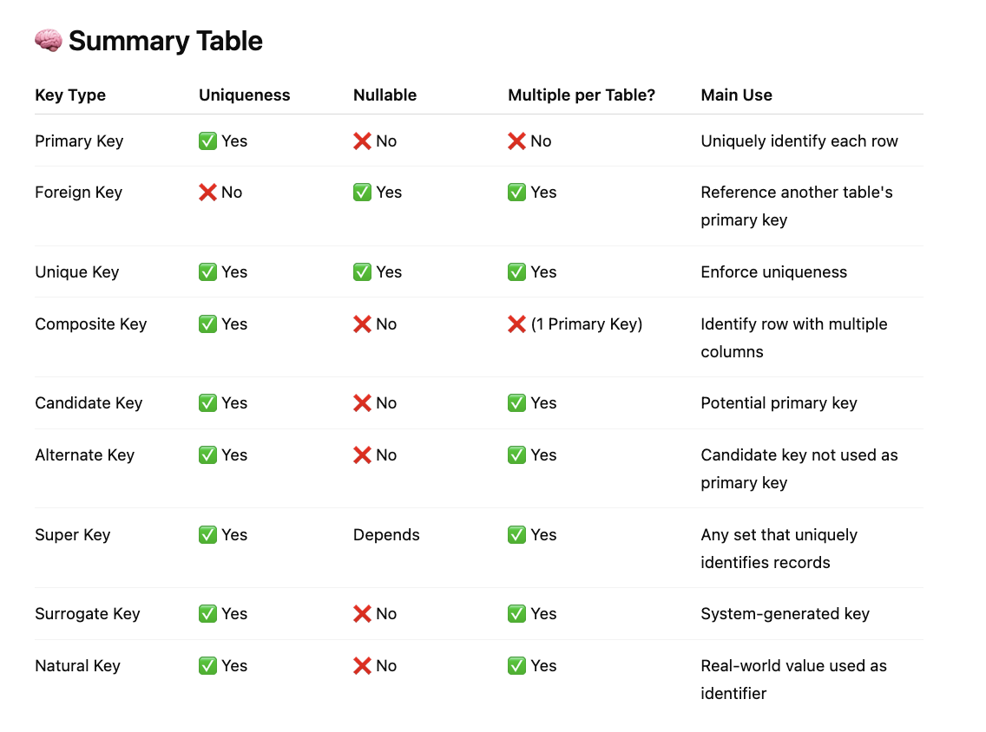

Normalization:

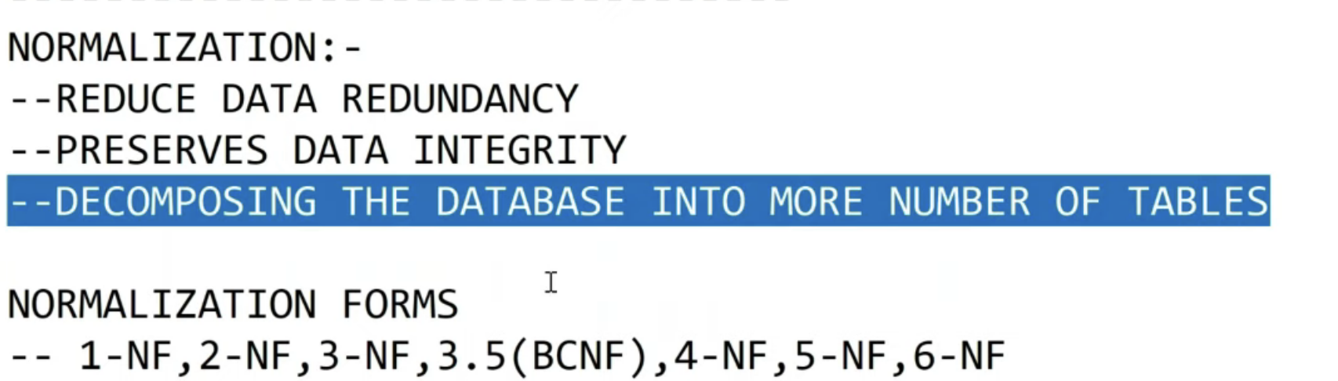

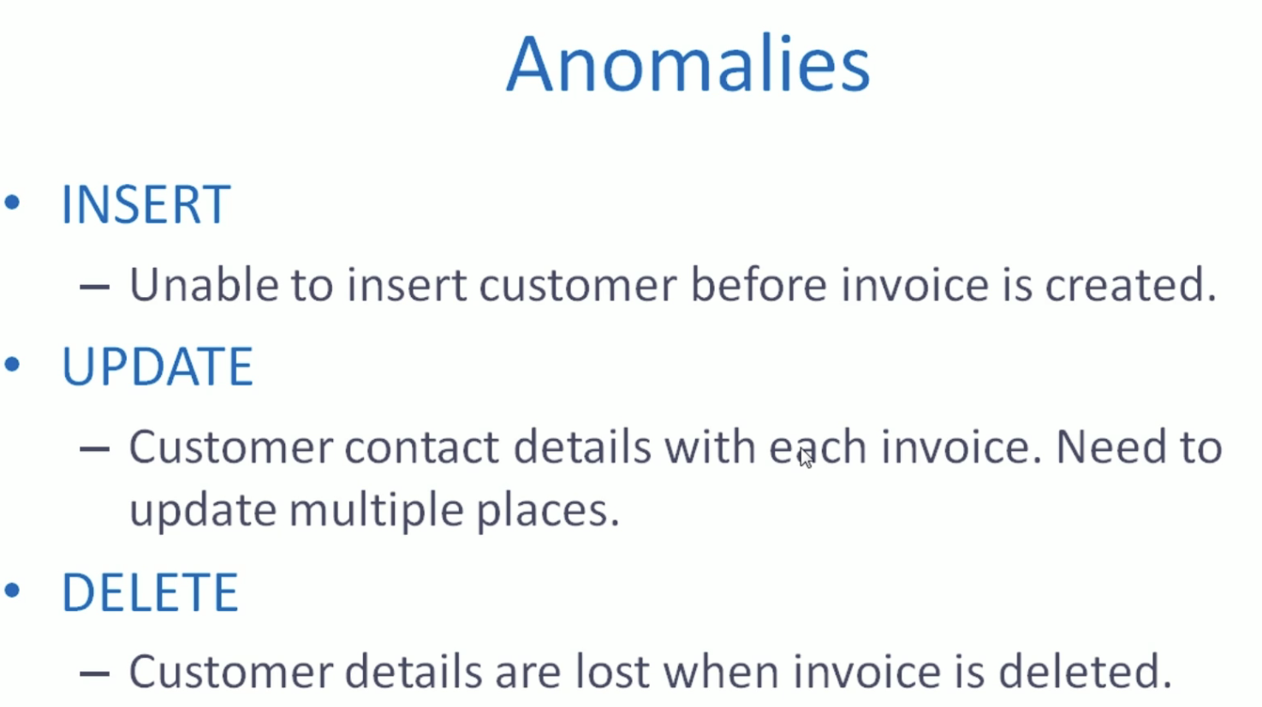

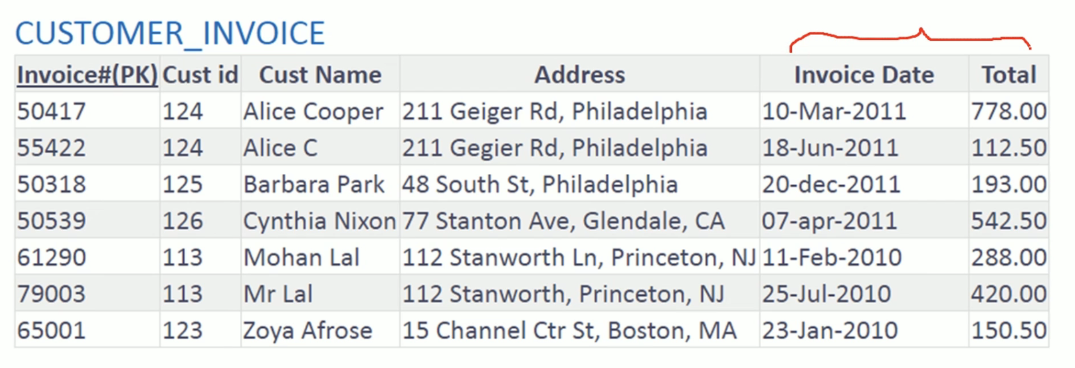

So this information should go. When we delete this invoice along with, we will also lose the customer information because we are storing the customer name address along with the invoice. It is undesirable that we lose the customer ID, customer name and address. So this is happening because we have stored customer information along with the invoice. So customer details are lost when invoice is deleted. So that is the delete anomaly. This is a different way of explaining the need of normalization. Objective of normalization is to isolate data so that additions, deletions and modifications of a particular information can be made in just one place. One fact at one place and at the right place. That is the sort of normalization. There are various normal forms. A table is said to be in a particular normal form if it satisfies a certain prescribed set of conditions. We have normal forms one and f two and f three and f, bcnf four and f and five enough. We will look into each of the normal forms in detail.

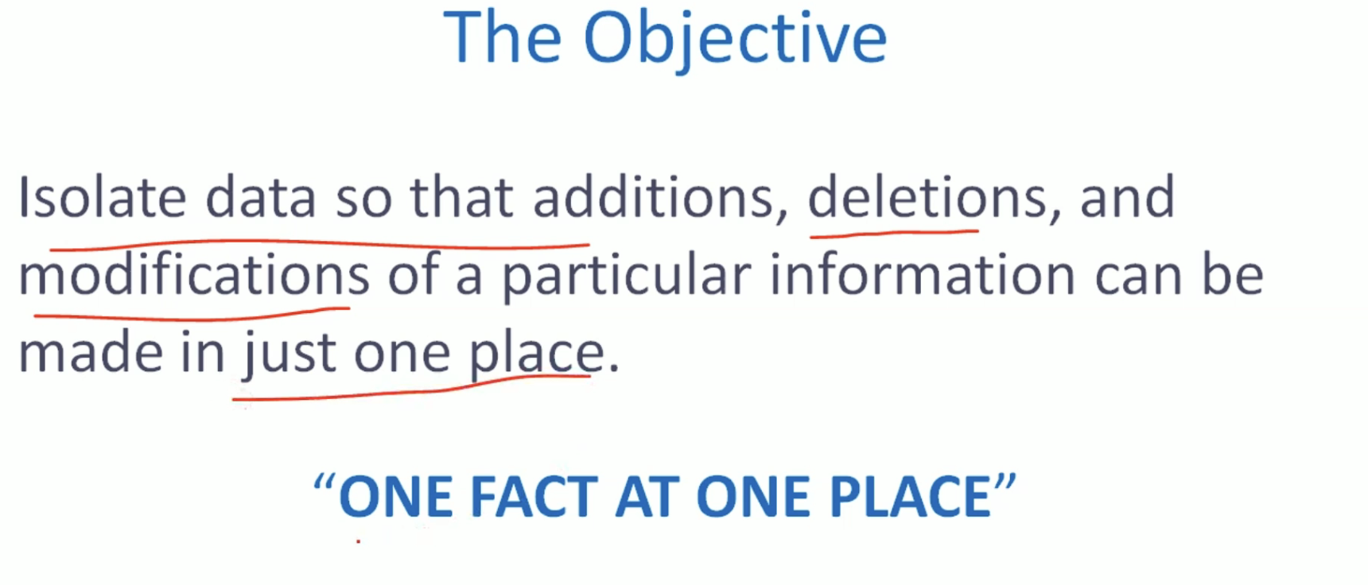

1NF:

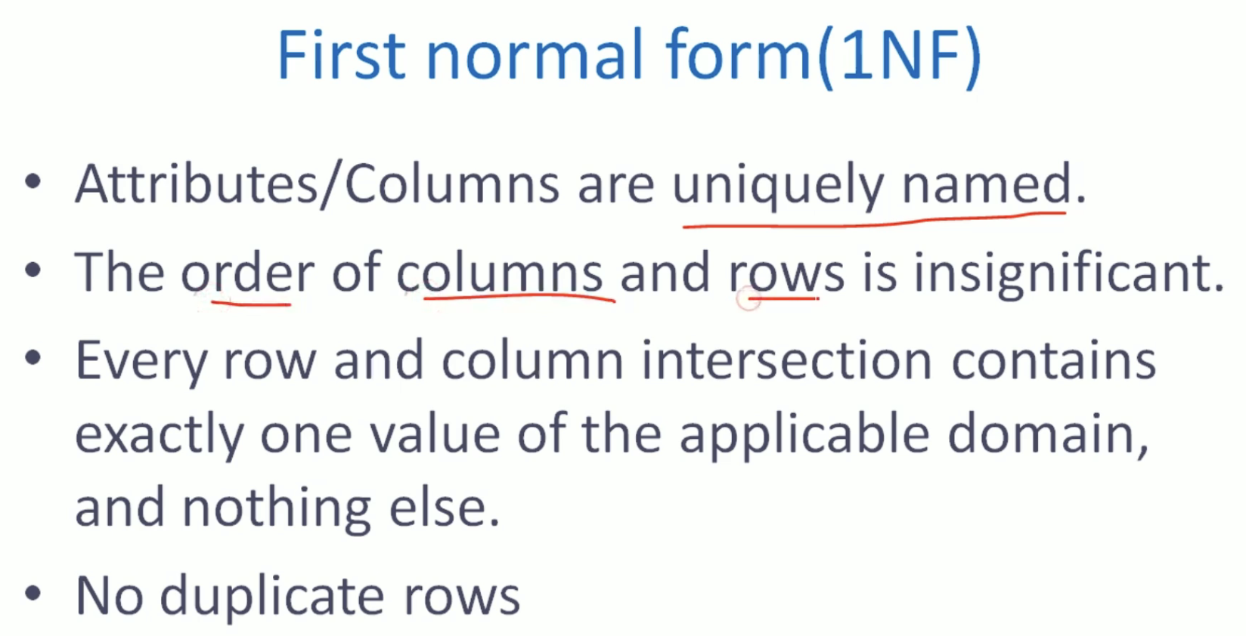

Invalid 1 NF:

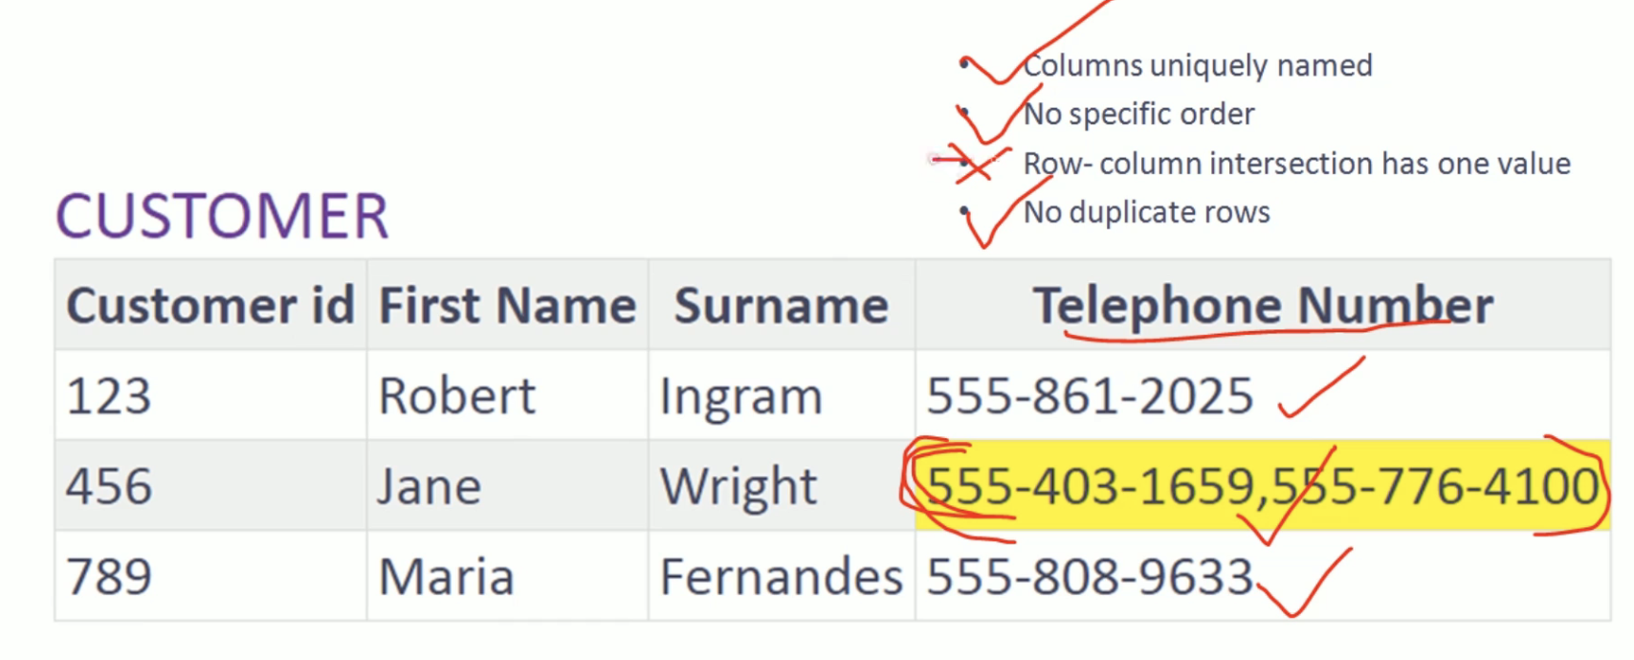



Data Integrity means not having duplicate records

1-NF:

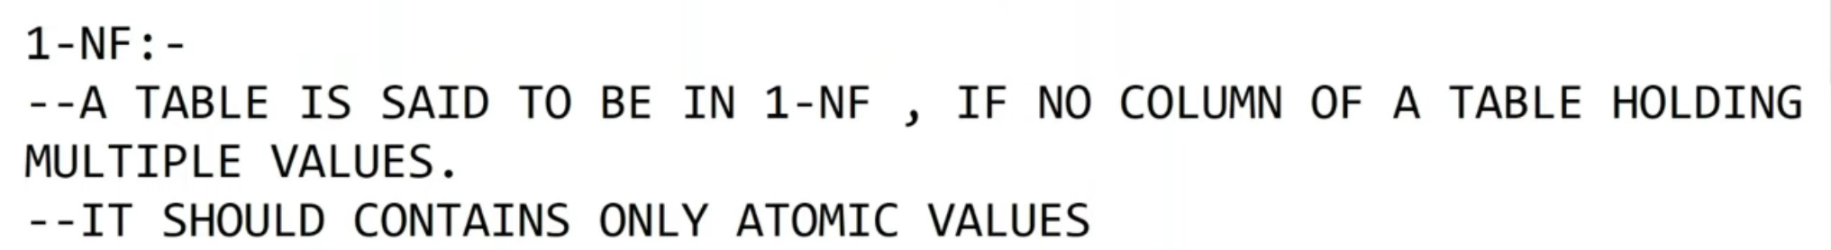

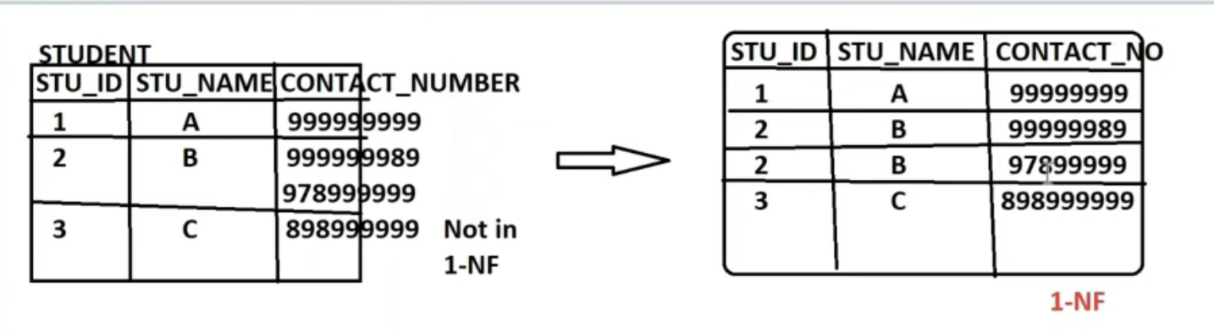

2 NF

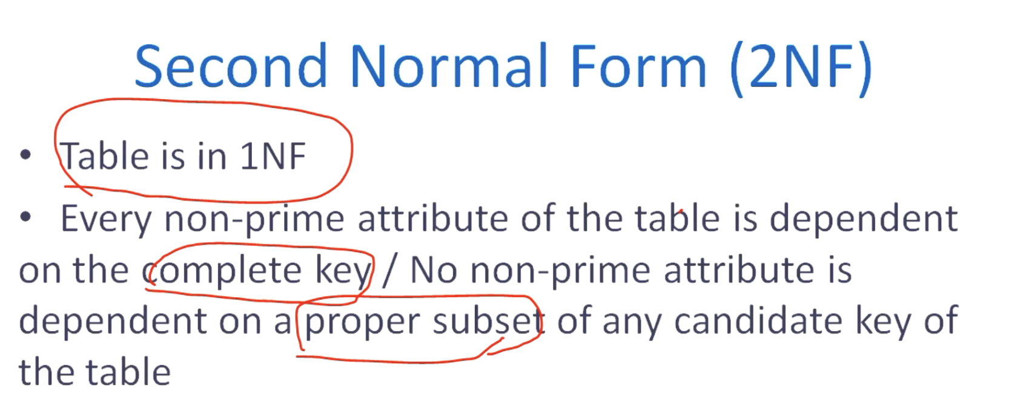

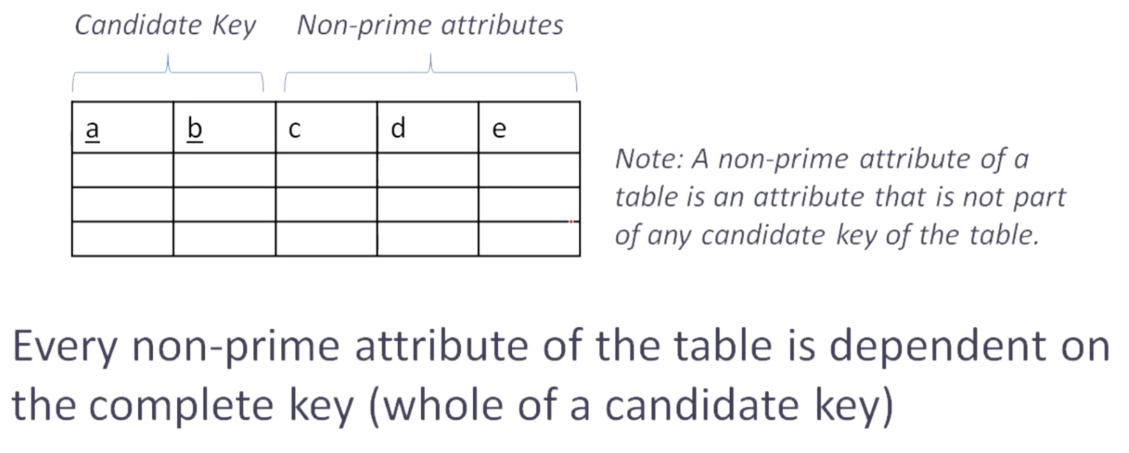

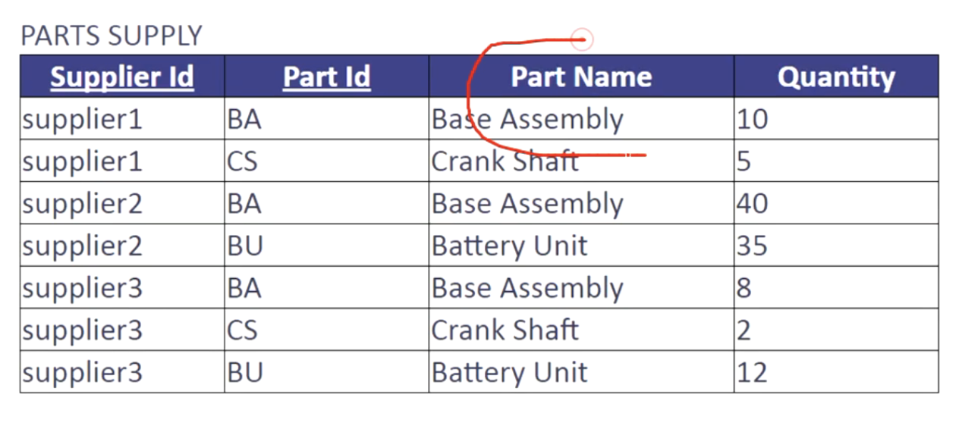

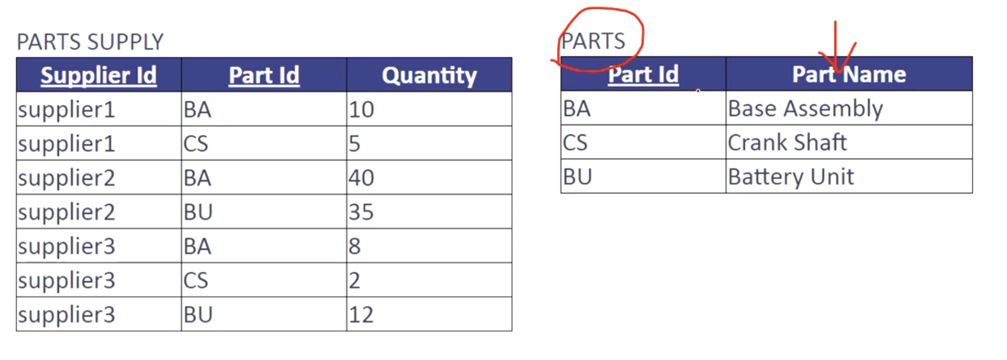

Now let's move to second normal form. Second normal form is about eliminating partial dependencies. It means every non-prime attribute of a table should be dependent on the complete key, not dependent on a part of the key. Here, non-prime attributes are attributes that do not participate in any candidate key. For example, here we have a table with five columns A, B, C, D, E, where A and B together makes a candidate key. C, D and E are non-prime attributes. They are non-prime attributes because they do not participate in any candidate key. In order to have this table in second normal form C, D, and E should be dependent on the complete key, which is A and B. If C, D, or E is exclusively dependent on either A or B, it means there is a partial dependency that has to be resolved. Let me explain this with a few examples. So here we have a part supply table supplier ID and part ID together makes the candidate key here. Part name and quantity are non-prime attributes because they do not participate in any candidate key. Let us try to understand what is the functional dependency here. And if any partial dependency exists. Let us look at the quantity column. For a given supplier ID and port ID, we expect to have exactly one value for quantity. It means. The quantity is determined by. The combination of supplier ID and part ID. This functional dependency is perfect. Now let's look at the part name. For a given part ID, we should have exactly one part name. It means the part name is determined by Part ID. In other words, there is a functional dependency between part ID and part name. Since part ID is not the complete candidate key within this table. But part ID is a subset of the candidate key attributes. It means this is a partial dependency. So the dependency between part name and part ID within this table is a partial dependency. In order to have this table in second normal form, we need to eliminate partial dependency. We need to decompose this table by moving the part name column out to a separate table where part ID is the candidate key. It may look like this. We have two tables. One is part supply and we have a separate table called parts. Where we associate part name with part ID so we don't have to repeat part name along with each supplier part. Let's have a look at another example. Here we have coarse batch table. It stores information about various courses and batches.

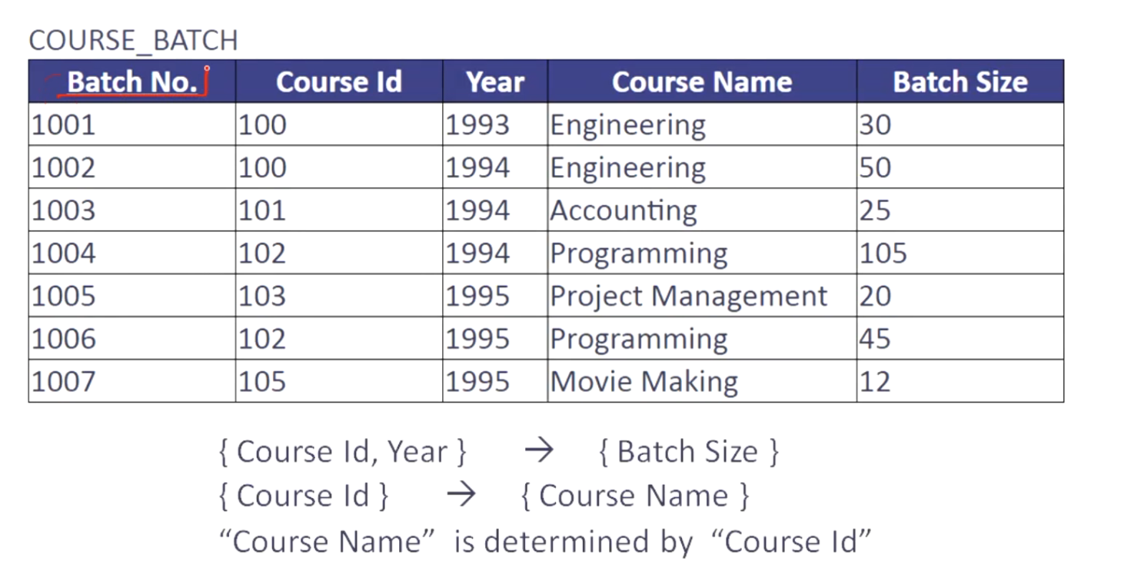

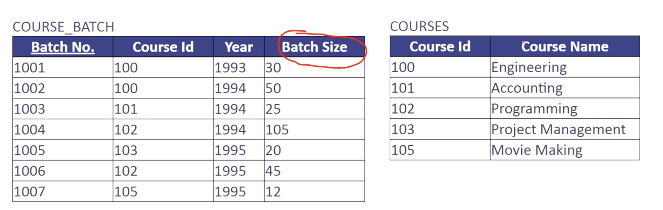

Batch number is the single column candidate key. Here we also designated this as a primary key. In addition to batch number, we have one more candidate key here. That is the combination, of course, ID and year. Course, ID and year can uniquely identify a badge because a particular course is conducted at Max once a year. So the combination, of course, ID and Ear can uniquely identify a badge. It means it can uniquely identify a record here. Course, name and batch size are non-prime attributes because they do not participate in any candidate key. Now let's look at the functional dependencies within this table. And let's see if any of them is a partial dependency. First, let us look at the batch size. For a given course ID and year, we expect to have exactly one value for batch size. Course ID and year determines batch size. This functional dependency is acceptable. Now let's look at the course name. For a given course id. We are expecting a unique course name. It means course ID determines course name. Since course, ID is not the complete key within this table. This particular functional dependency is a partial dependency. So we need to eliminate this dependency from this table. In order to eliminate this partial dependency, we need to decompose this table by moving Coe's name column out to a separate table where course ID is the candidate key. It may look like this. So here we have a course batch table. The only non-prime attribute is batch size. And the course name is moved to a separate table. Where? Where we associate course name with course ID. So we don't need to repeat code name with each patch. Okay, let's summarize second normal form and conclude the conditions for a table to be in second normal form are first, the table should be in first normal form. The second, Every non-prime attribute of the table should be dependent on the complete key. In other words, no non-prime attribute is dependent on a proper subset of candidate key. Thank you.

3NF:

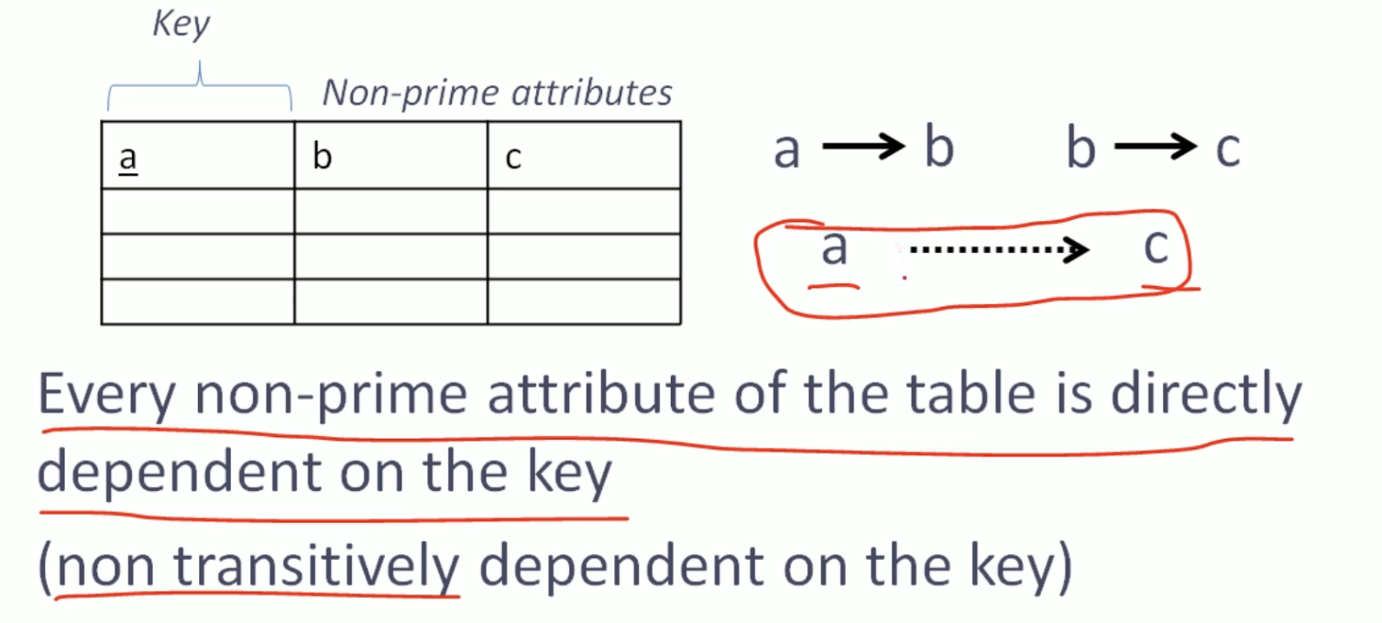

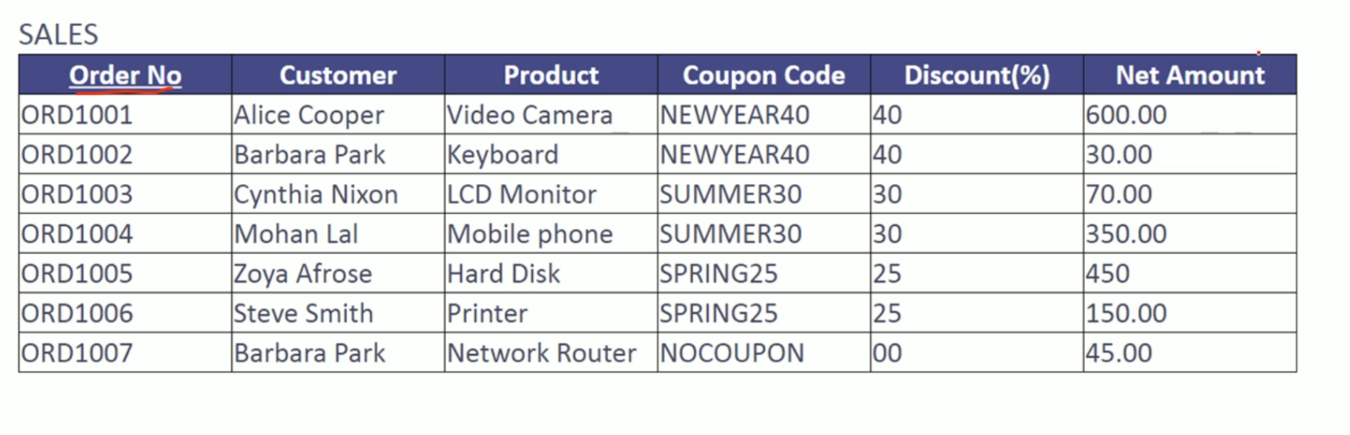

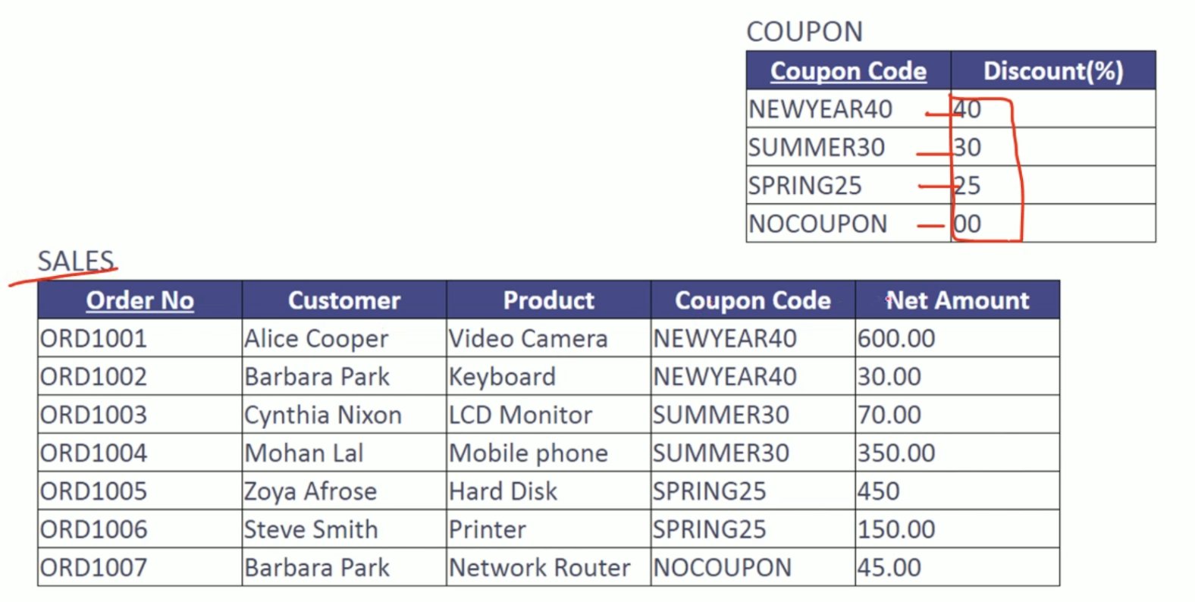

A table is said to be in third normal form if it satisfies all the requirements to be in second normal form. And every non-prime attribute of the table is directly dependent on the key. In other words, every non-prime attribute of the table is non transitively dependent on the key. Let's say we have a table with three attributes A, B and C, where A is the key, and B and C are non-prime attributes. The functional dependencies within the table are A determines B and B determines C. This pair of functional dependencies implies that a transitively determined c. Or C is transitively dependent on a. This is a transitive dependency and we need to eliminate transitive dependencies to bring a table to third normal form. Let me show you with the help of a few examples how to identify and eliminate transitive dependencies from a table. See. Here we have a sales table. Each sales is identified using an order number. All other attributes are non-prime attributes. Or we may call them non-key columns. All non-prime attributes in this table are functionally dependent on order number. Because for a given order number we have exactly one value for customer product, coupon code discount and net amount. However, if you look at the semantics of coupon code and discount, you may find there is a consistent discount percentage for a given coupon code. For example, if you look at New Year 40, it always has 40% discount. If you look at summer 30, it always has 30% discount. So this is a functional dependency between coupon code and discount. Discount is determined by coupon code or discount is functionally dependent on coupon code. In other words, discount is not directly dependent on order number. It is transitively dependent on order number. So here there is a transitive dependency. To eliminate this transitive dependency, we need to move the discount column out to a separate table where coupon code is the key. It looks like this. We have discount percentage associated with the corresponding coupon code in a separate table. Each sales transaction do not keep track of discount percentage. It keeps track of coupon code. We can always derive the discount percentage with the help of coupon code.

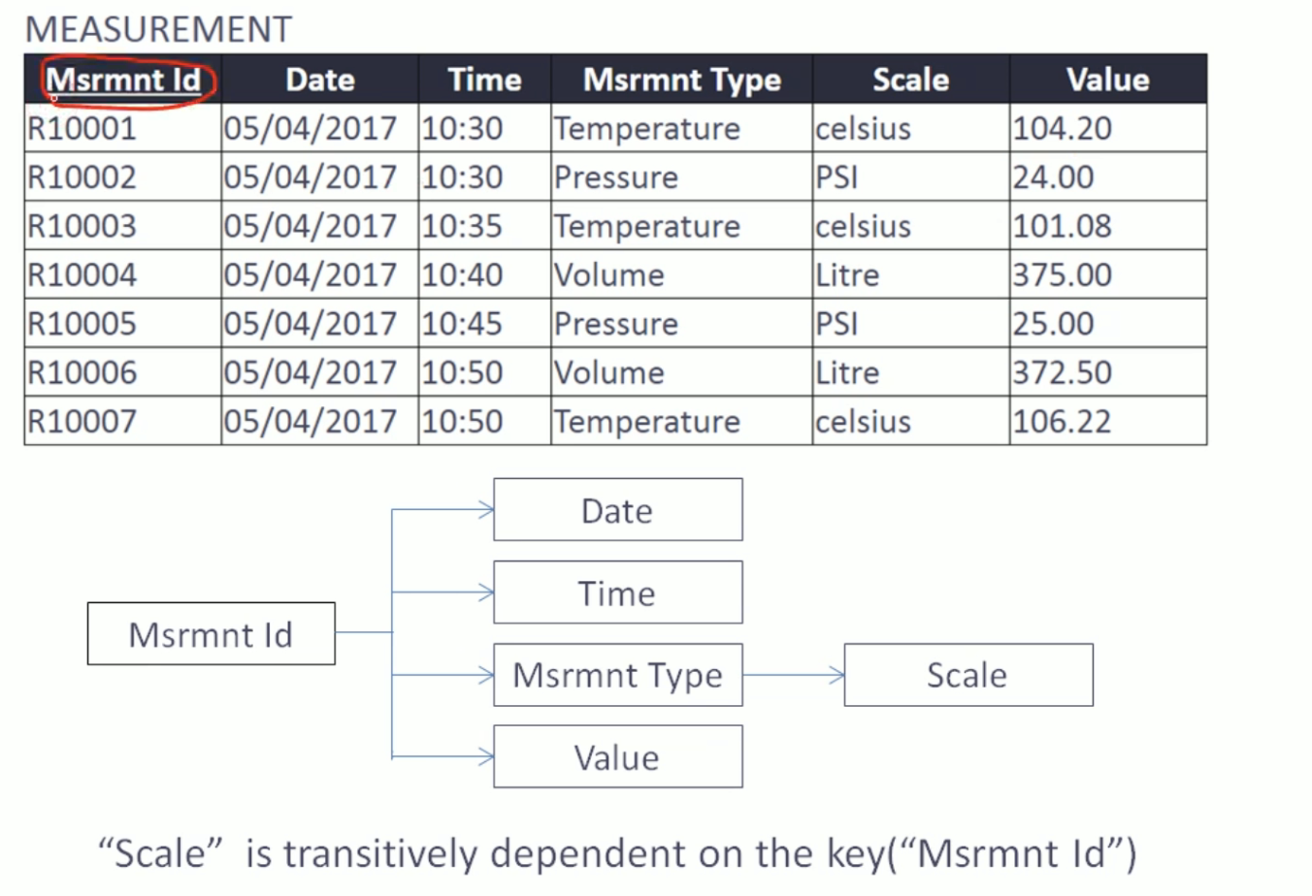

Let us look into another example. Here we have a measurement table. Certain physical parameters of an object is measured and recorded in this table. A row is created for each measurement event and identified by measurement ID. Other than measurement ID, all attributes are non-prime attributes or non-key columns. If you look at this table, there is a semantics around measurement type and scale. The scale for a particular measurement type is always consistent. For example, temperature is always measured in Celsius. Pressure is always measured in PSI. Volume is always measured in liter. And other columns in this table do not have any mutual dependency. Let's have a look at the functional dependencies within this table. We have a diagram that demonstrates functional dependencies. Here. Date time, measurement, type and value are functionally dependent on measurement ID, and that's a direct dependency. If you look at scale, scale is functionally dependent on measurement type because for a given measurement type, we always have a consistent scale. It means scale is transitively dependent on measurement id. To bring this table to third normal form. We need to eliminate this transitive dependency. We need to decompose this table by moving scale column out along with the corresponding measurement type. See we have decomposed that table and moved the scale to a separate table where scale is associated with measurement type. We do not record the scale along with each measurement event. We just need measurement type. Scale can be derived. Before we conclude third normal form, I would like to emphasize one very important point. Although we've been using a sample set of data to demonstrate functional dependencies, we cannot infer functional dependencies by looking at a sample data. Functional dependencies are a consequence of semantics around the data elements being represented. For example, for a given coupon code, we have a consistent discount percentage. This is a business rule which exists outside the database. Database design needs to appropriately reflect these business rule by identifying corresponding functional dependencies and thereby having appropriate logical representation of data. Okay. Now let us summarize the first three normal forms. Each non-prime attribute should be directly dependent on the complete key. This is a definition which accommodates the important aspects of first normal form, second normal form and third normal form. Here. The term key indicates that we have the unique rows and a way to identify rows in the table. The term complete. Complete key indicates there are no partial dependencies. The term directly dependent discards the possibilities of having transitive dependencies. Effectively a table is in third normal form if each non-prime attribute depend on the key. The wall key and nothing but the key.

Transitive dependency means if you change non-key column it should not change other non key column, if it’s changing other non-key column then it’s not in 3NF

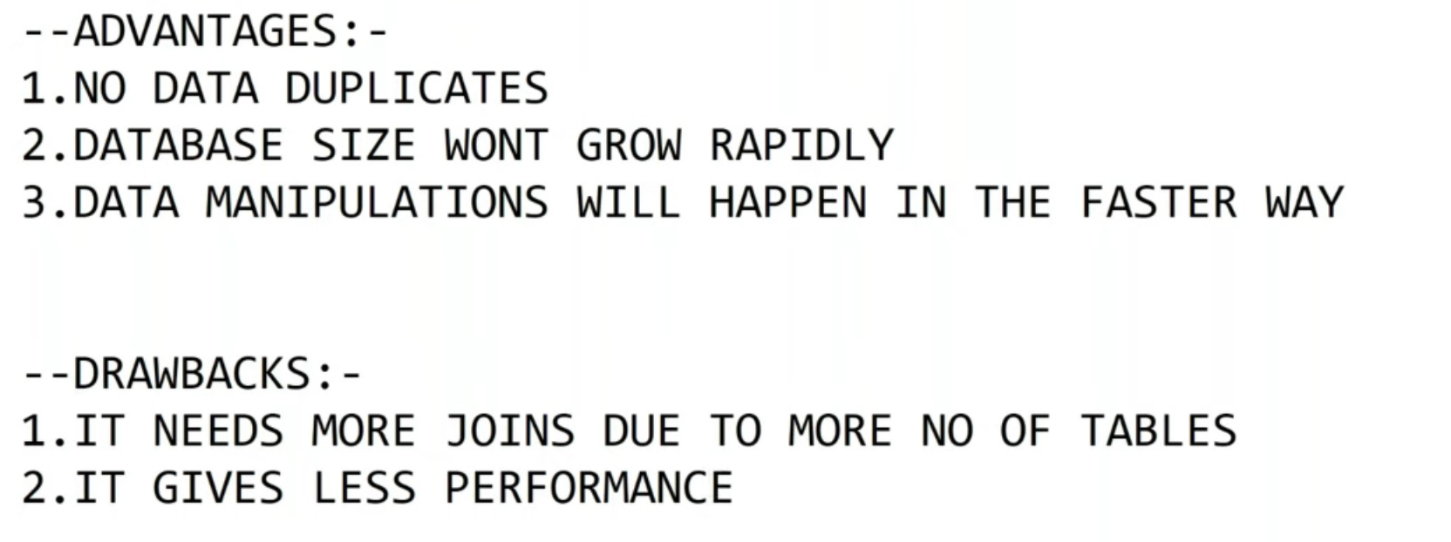

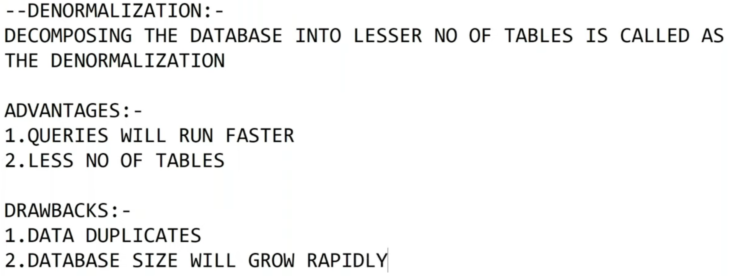

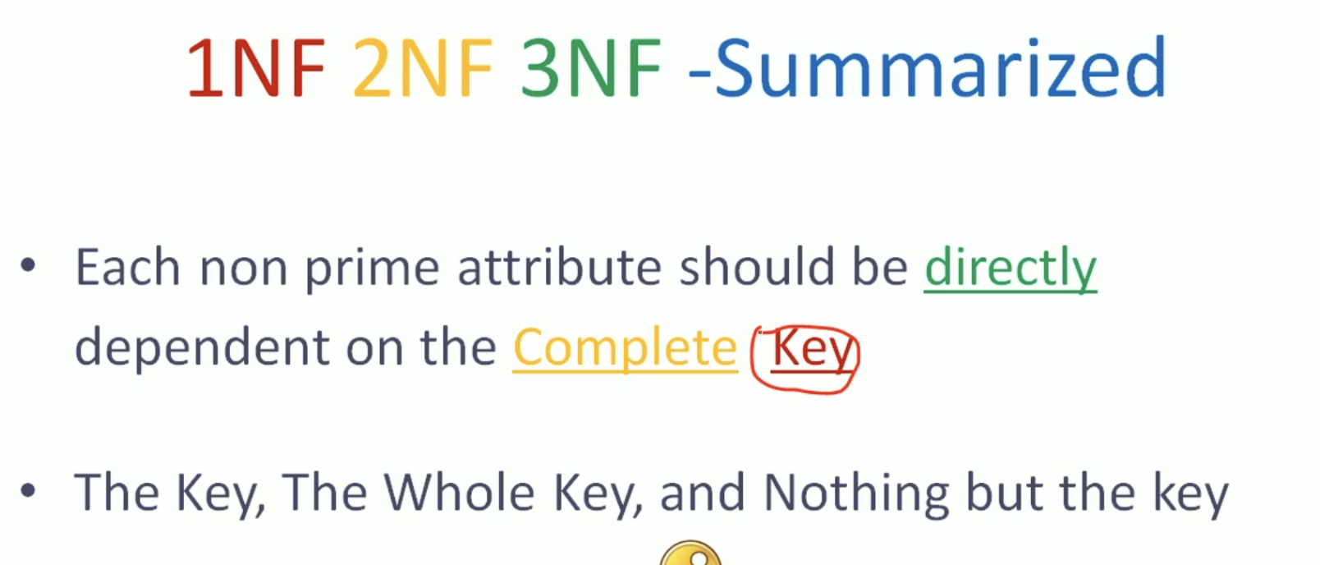

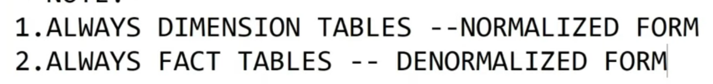

BCNF:

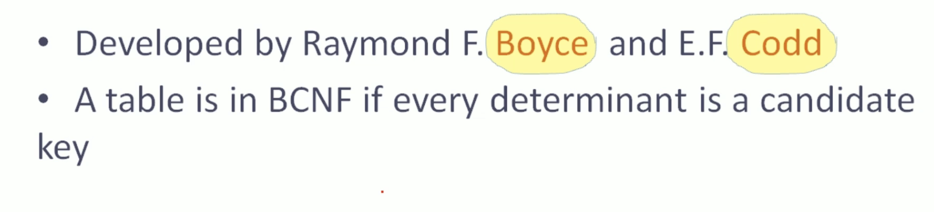

No determinant except candidate keys. A table is in bcnf if every determinant is a candidate key. In second normal form. We have eliminated partial dependencies in third normal form. We have eliminated transitive dependencies. Bcnf do not ask us to eliminate any specific type of functional dependencies. It clearly defines what type of functional dependency can be retained. The only type of functional dependency that is allowed in a bcnf. Table are functional dependencies where the determinant is candidate key. We often consider Bcnf is a stronger version of third normal form. If a table is in third normal form, non-prime attributes are in good shape because they are directly dependent on the complete key. However, even after achieving third normal form, there can be some issues with prime attributes. There can be some undesirable dependencies between prime attributes that is addressed by bcnf.

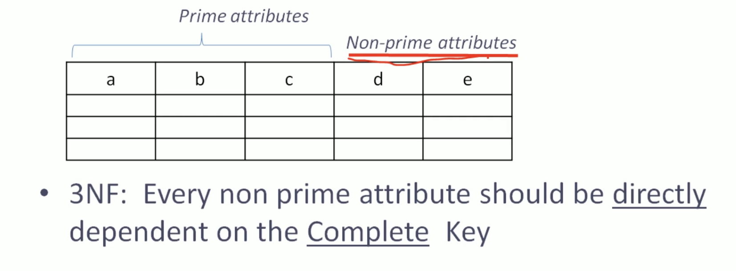

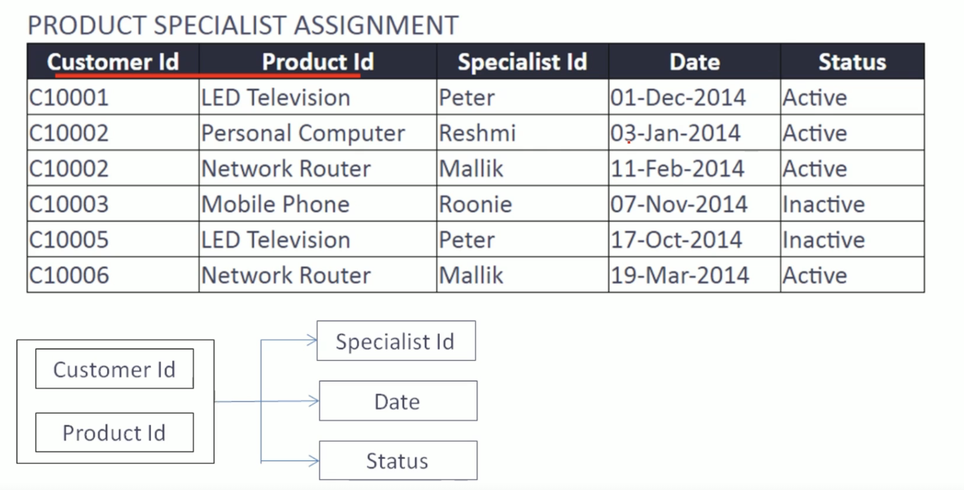

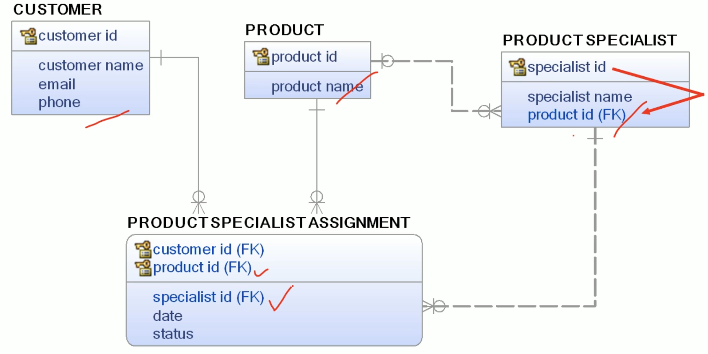

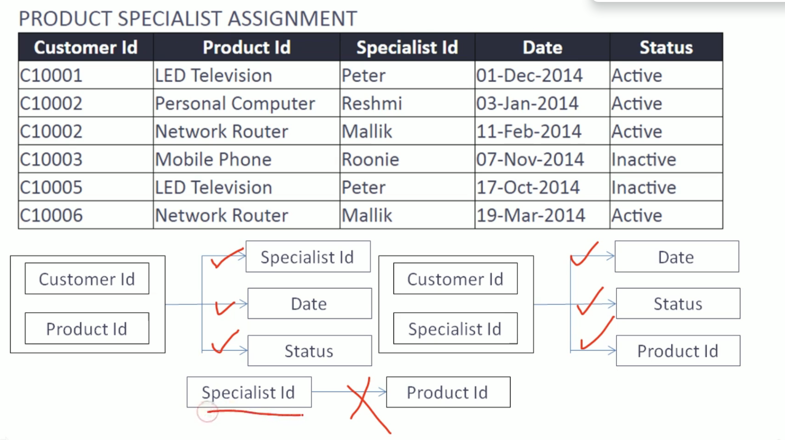

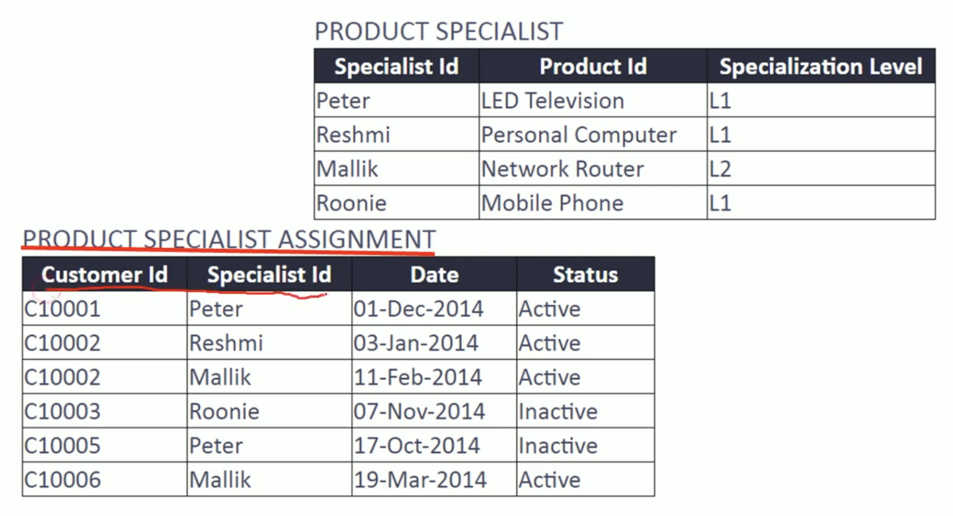

Now, let's have a look at one example. So here we have a product specialized assignment table. Each customer can buy one or more products for each product purchase. A specialist is assigned to support the customer. You also have date and status recorded. The combination of customer ID and product ID can uniquely identify the records in this table so we can consider the combination of customer ID and product ID is a candidate key. So here we have the set of functional dependencies with the candidate key customer ID and product ID. Now let's have a look at the data model where we have product specialist assignment table and related tables. See here we have a separate customer table. Which records the set of all customers identified by a customer ID. We have a separate table called product, which records the set of all products identified by product ID. Then we also have a product specialist table where we have this set of all specialists along with their specialization. Here. One important thing is that a particular specialist is specialized in only one product. So specialist can determine product ID in this table. Since we have both attributes in product specialist assignment table, we have the product ID and we also have the specialist ID. Since we have both these attributes in product specialist assignment table, the functional dependency between these two attributes will be reflected in this table as well. Let's have a look at the sample data. See here we have specialist ID to make it readable. We are using the descriptive text for product ID and specialist ID, So let's look at the specialist ID, Peter. Peter is specialized in product called LCD television. So wherever Peter appears as a specialist, we will find a lead. Television is the product. Maliki is specialized in network router. So wherever Malik appears, the product ID is going to be network router because we have a functional dependency between specialist ID and product ID. Specialist ID determines product ID. So now we have identified this set of functional dependencies. We have a candidate key customer ID, product ID combination which determines specialist ID, date and status. Then we have one more functional dependency where specialist ID determines product ID. Here. Another important thing is that the combination of customer ID and product ID can uniquely identify records within this table, and also specialist ID can determine product ID. In that case, the combination of customer ID and specialist ID can also uniquely identify records within this table. It means we have one more candidate key in this table. The customer ID and specialist ID combination is also a candidate key. It can determine the date, status and product ID. These two candidate keys are overlapping candidate keys because we have at least one attribute in common. See, customer ID is a common attribute. Now, if you look at the table from a normalization perspective, you can find only date and status are non-prime attributes. All other attributes are prime attributes. Customer ID, Product ID and specialist ID are prime attributes because they participate in candidate keys. Since every non-prime attribute directly dependent on the complete key, this table is in third normal form from a bcnf point of view. We need to make sure that we do not have any determinant other than candidate key. So let's have a look at all the functional dependencies. All these functional dependencies are acceptable because the combination of customer ID and product ID is a candidate key. Here, these functional dependencies are also acceptable because the determinant is candidate key. However, if you look at this functional dependency, this is not acceptable for bcnf because the determinant is not a candidate key. To bring this table to Bcnf, we need to eliminate this functional dependency. It means we need to move this particular product ID column out to a separate table where specialist ID is the key. So we need to move this product ID column. If we already have a table where specialist ID is the candidate key and product ID exists, we may not need to create a separate table. If we do not have a table, we need to create them. The final design may look like this. We have product specialist assignment table. We have taken out the product ID. The combination of customer ID and specialist ID is the candidate. Key date and status are non-prime attributes. We have a separate table called product specialist where specialist ID is the key. So when a specialist is assigned for a customer, we don't need to keep track of the product in this table. We only need to keep track of the specialist ID. If we know the specialist ID, we can determine the product by looking at this table.

Data Model:

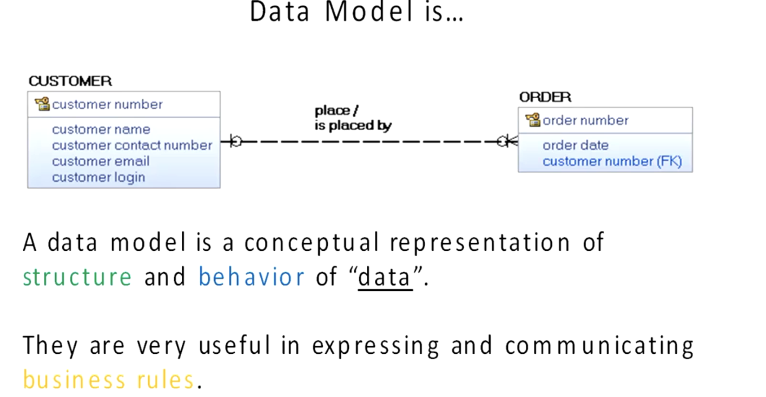

Entity Relationship:

Entity relationship model is a method for modeling business data without a tight dependency on the underlying database.

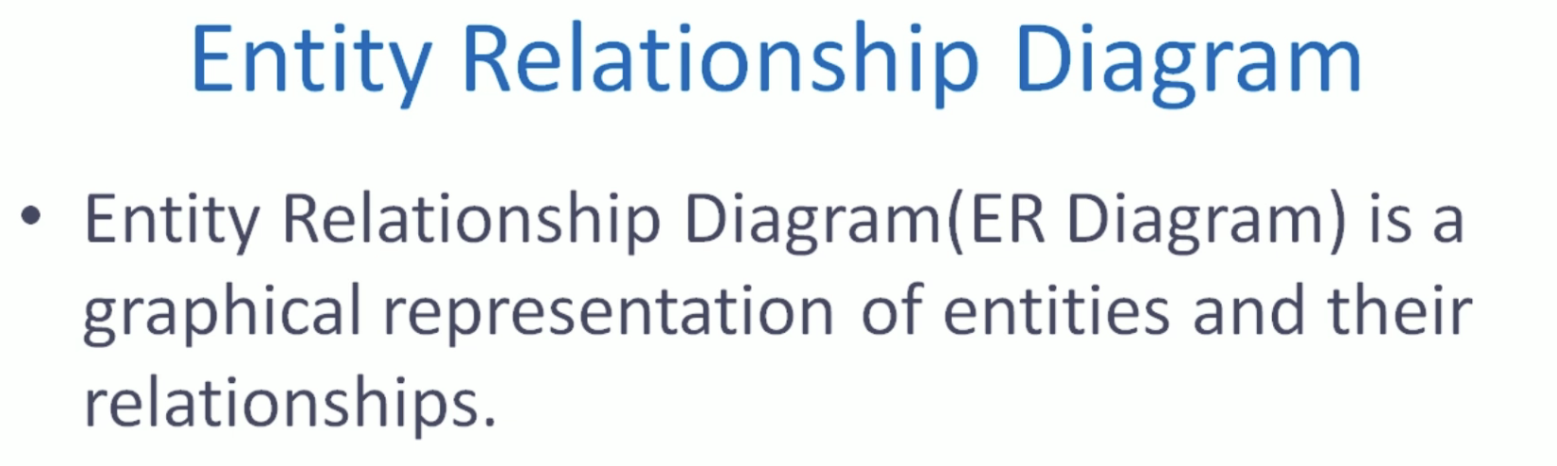

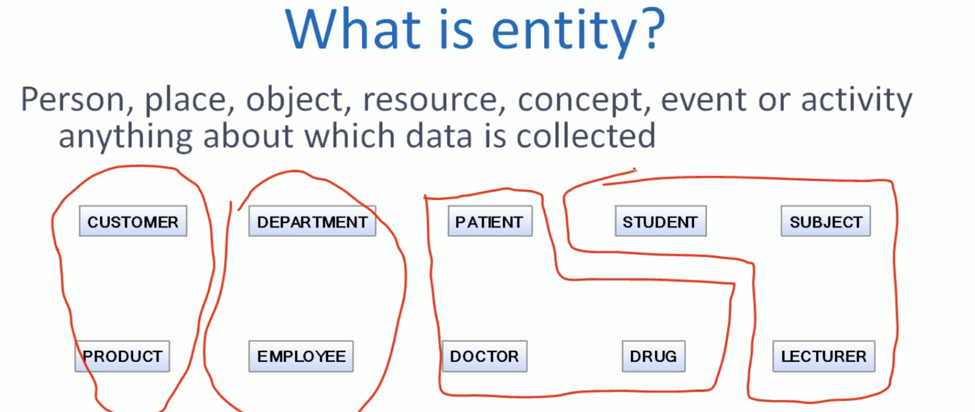

What is entity? Entity can be anything about which data is collected. It can be a person. It can be place, object, resource, anything which is important and significant in a particular domain. Where we are developing a data model in a business environment, we might find customer and product as entity types. In an organization, we might find department and employee are significant entity types. In a hospital, we may find patient doctor truck in a university environment. We may find student subject lecturer. These are sampled entities applicable to different domains.

Attributes:

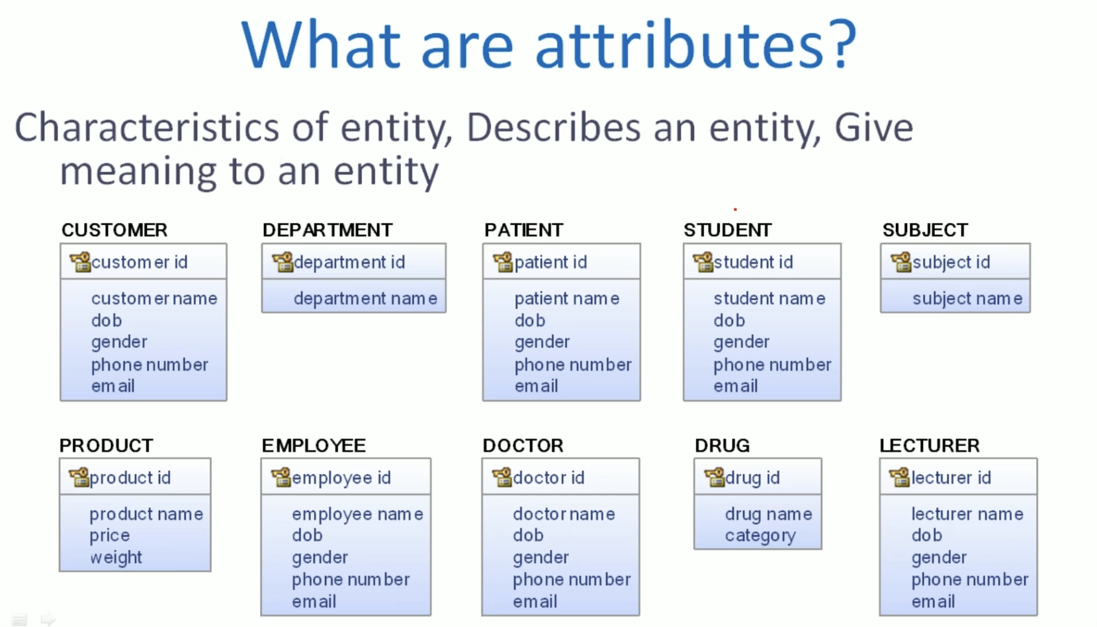

Then what are attributes? These entities are not meaningful if you do not have a set of attributes to describe them. So attributes are characteristics of entity and they describe them. They give some meaning. So you can find this is an entity with a set of attributes, one or more attributes we will use to identify one instance of entity. Here. Each customer instance is identified using a customer ID attribute. In this representation at the top, what you see is the name of the entity. And in the first box we have the primary key attributes, and the remaining attributes are non primary key attributes.

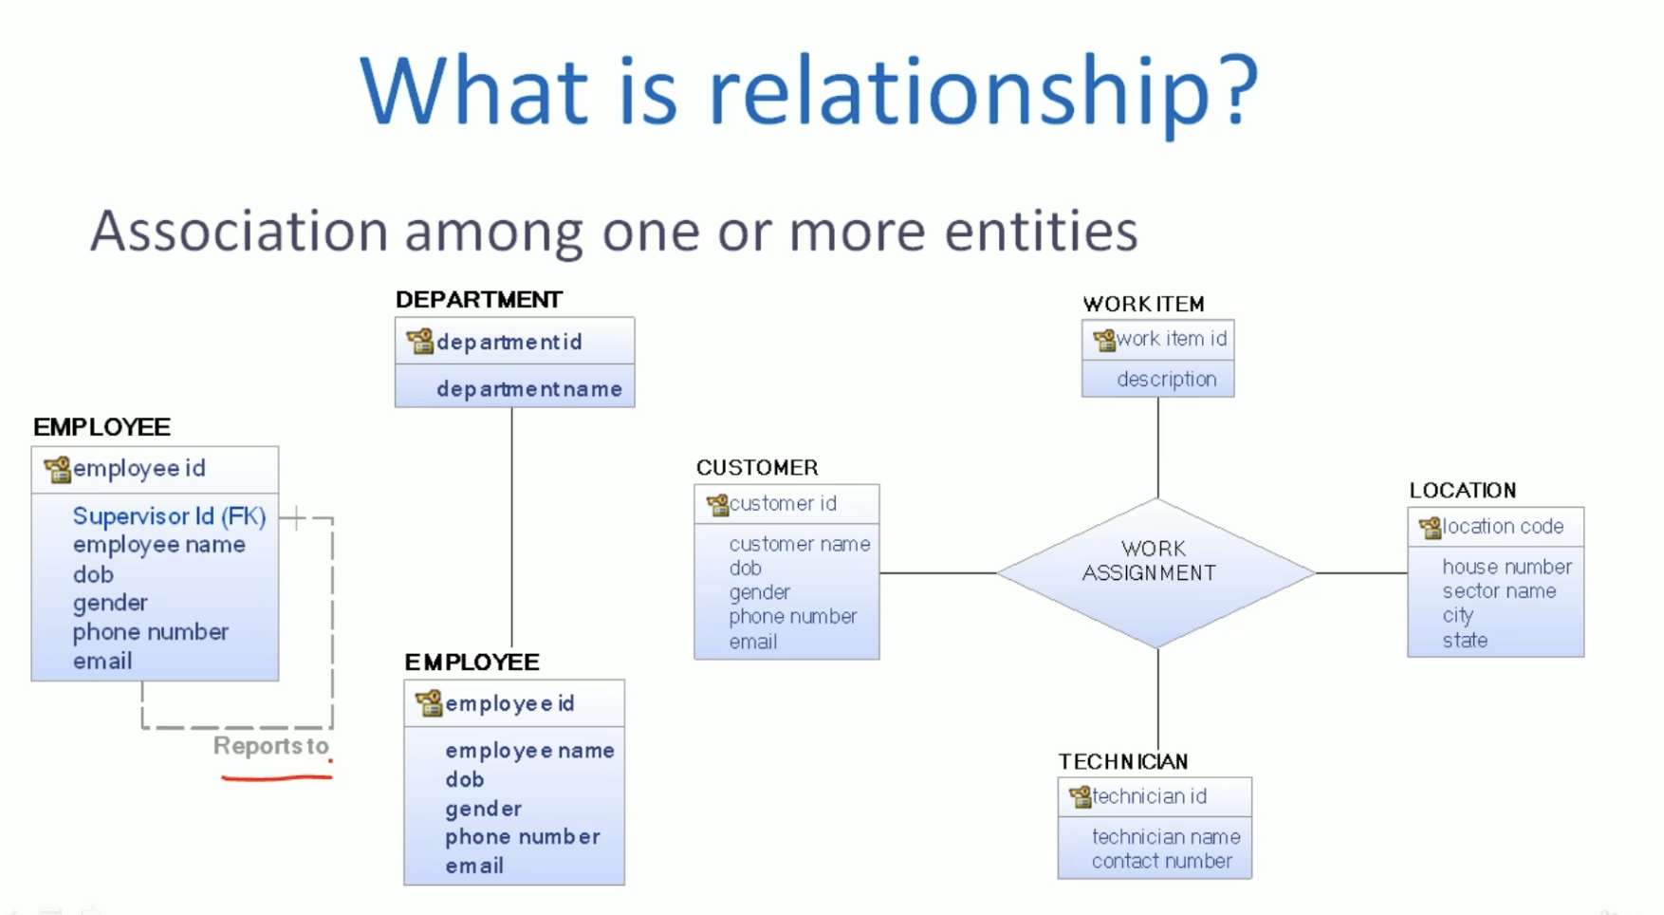

Then what is relationship? Relationships are association among one or more entities. It can be an association within an entity or between two entities, or it can be an association between many entities. For example. One employee instance reporting to another employee instance. So that is the relationship within employee entity type. Each employee belongs to a department, so it is a relationship between department and employee. Here we have two entity types participating in that relationship. A relationship can be among many entities. For example, a particular work item was assigned to a technician for a customer at a particular location. So this work assignment is a relationship between customer work, item, location and technician. This work assignment can be perceived as a relationship or even an entity. It is up to the user to decide which representation is most suitable. So back to entity relationship diagram. We have discussed what is an entity and attributes. We have discussed what are relationships. Now the next important step is to understand a notation so that we can start drawing entity relationship diagrams.

Notations:

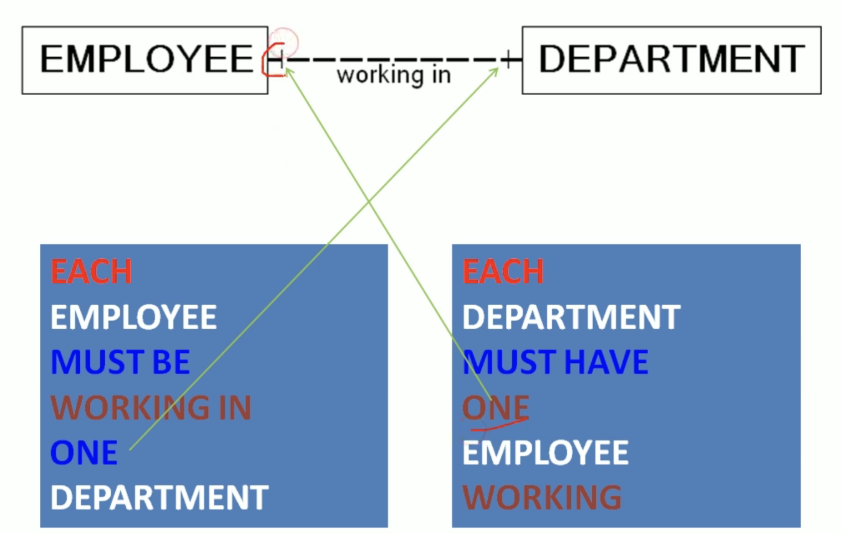

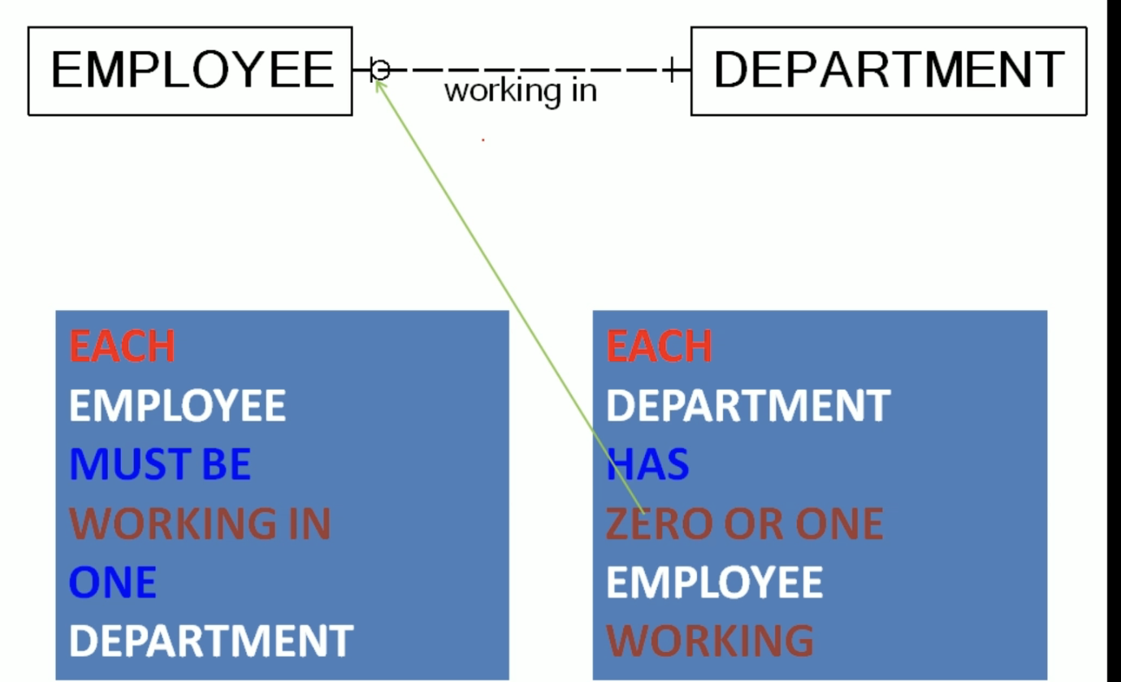 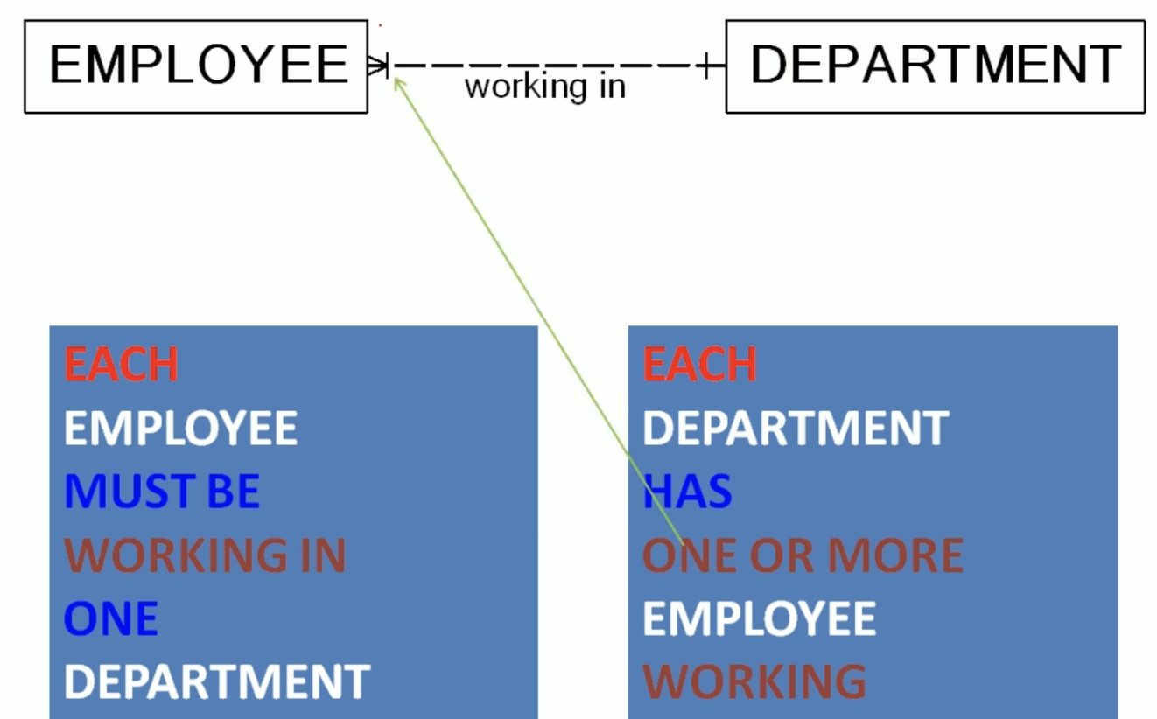

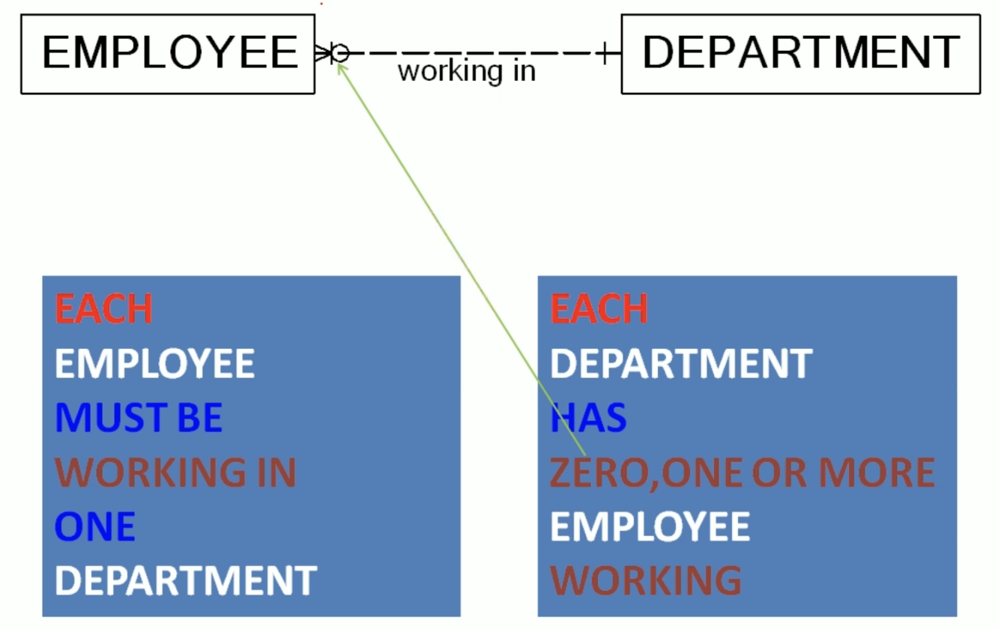

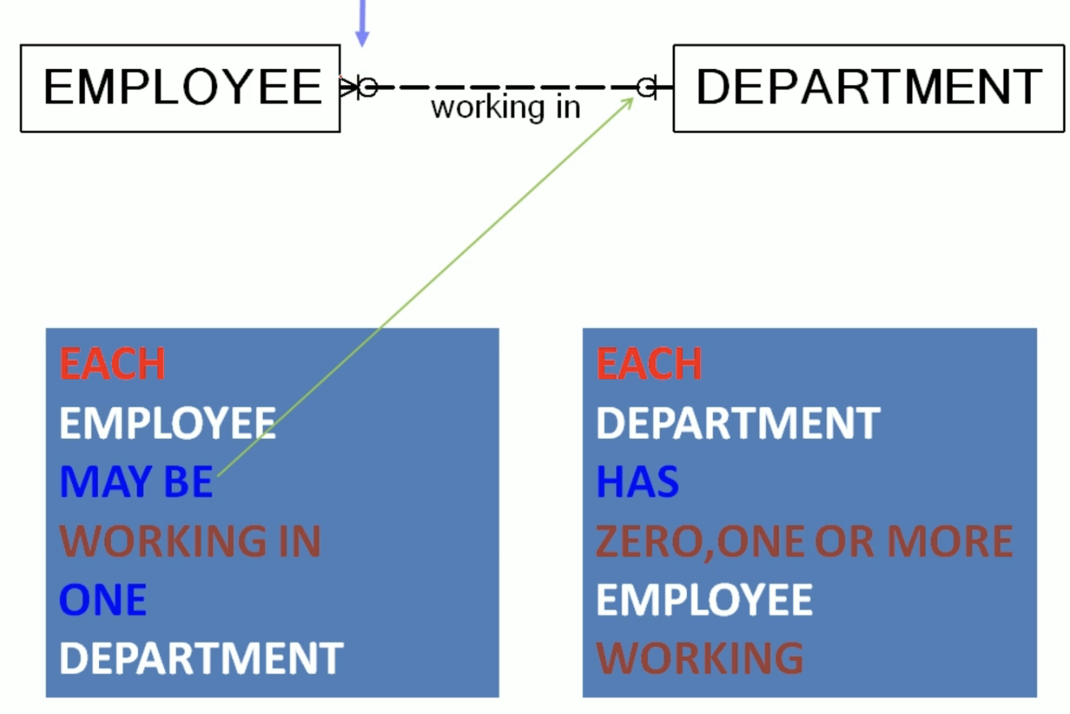

Many to Many:

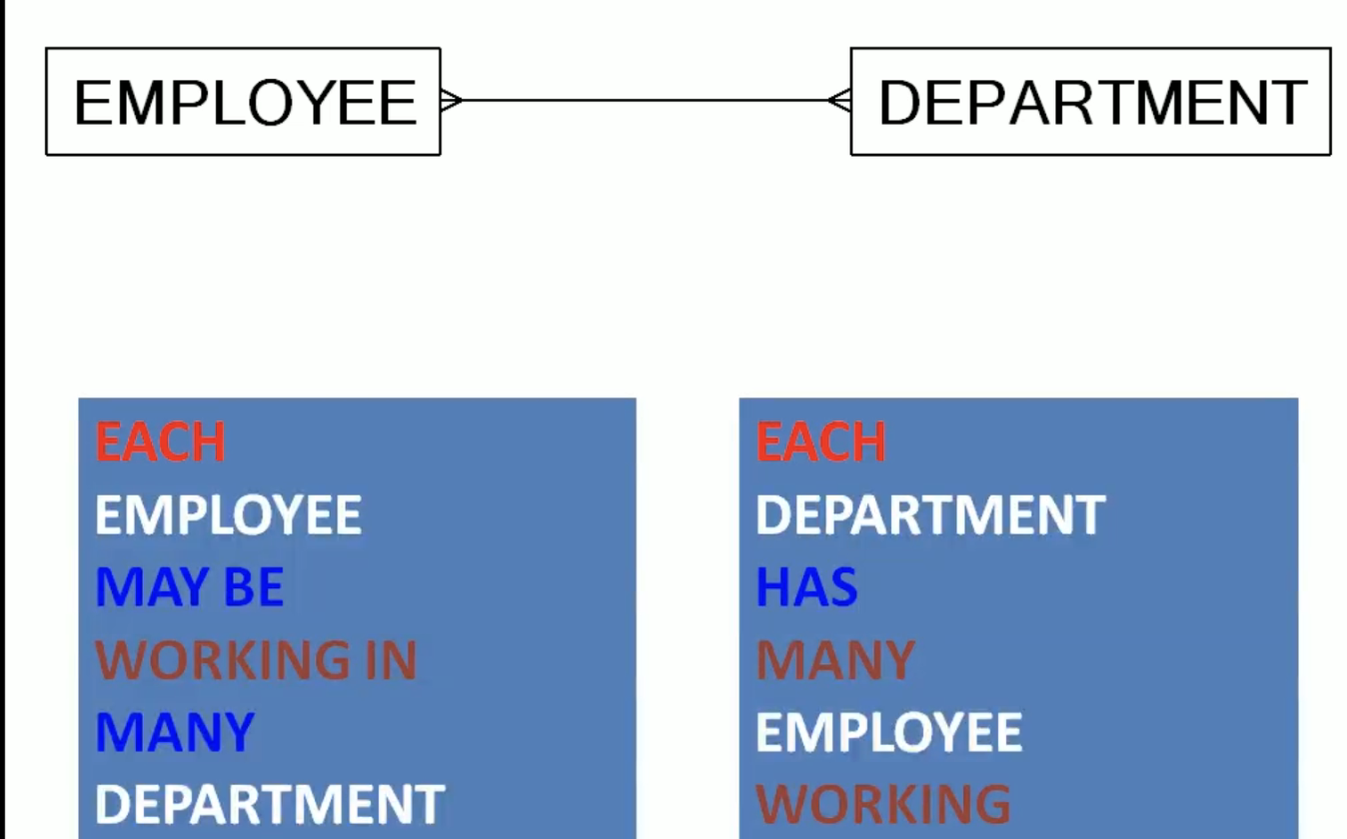

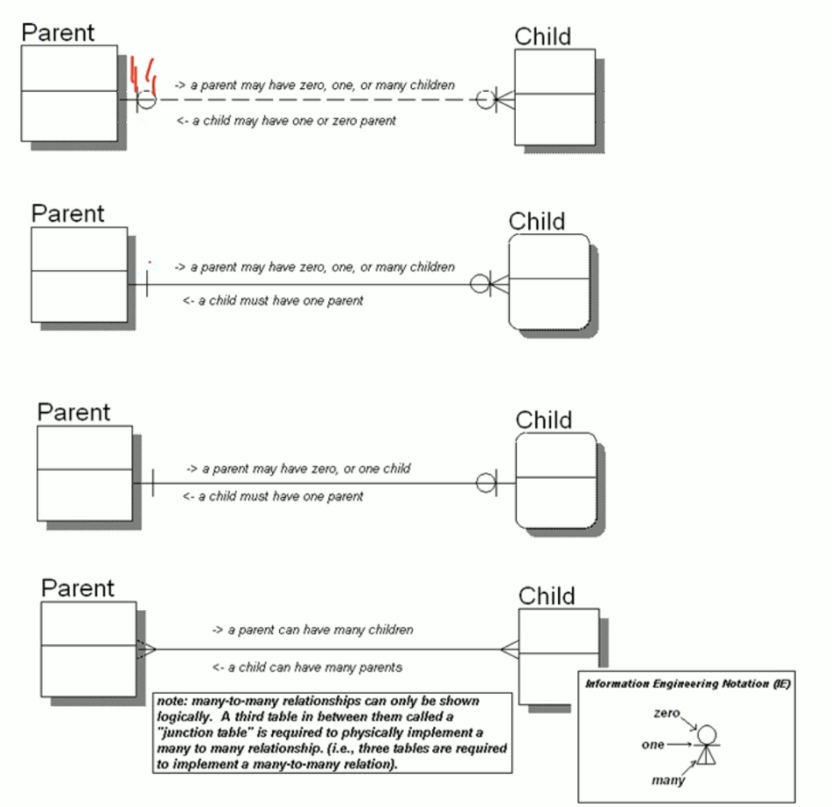

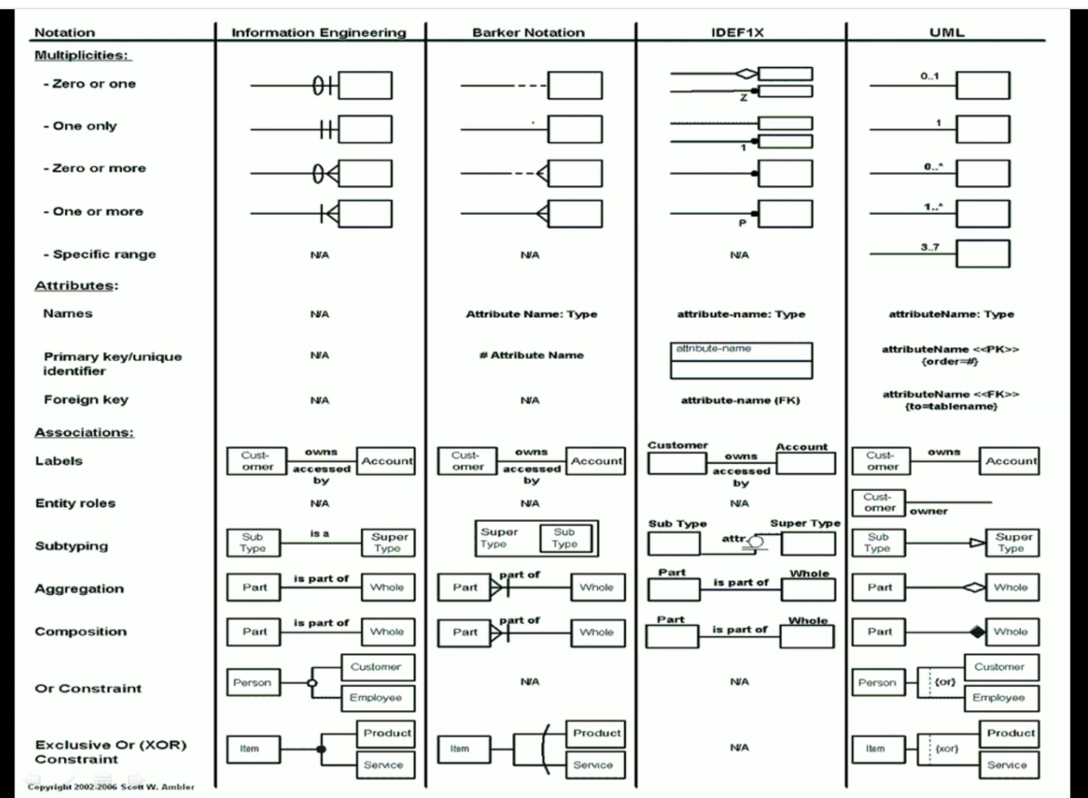

Now we are going to understand information engineering notation. So we will look at a very simple entity relationship diagram and learn the notation. Look at this diagram. This is a very simple diagram. We have two entities and a line between them that indicates a relationship, and we do not have attributes in this diagram because it is not very important here. What is the relationship between employee and department? It can be anything here. It is employee working in department. We are going to add additional symbols and discuss the meaning. So here we have an additional symbol. So how can we read this entity relationship diagram? If we read this diagram from left to right, we can read it. Each employee must be working in one department. If I read it from right to left, I can read. Each department must have one employee working. See, each employee must be working in one department. This particular symbol indicates one that is the cardinality or multiplicity. Each department must have one employee working. So this one is mentioned on the other side. So that's the multiplicity from department to employee. See in this diagram. We have a small change here. How can we read this entity relationship diagram from left to right? Each employee must be working in one department. When we read it from right to left. Each department may have one employee working. So here this has become 0 or 1. So each department has 0 or 1 employee working. Let's see one more additional symbol. Now, how can we read that from left to right? There is no change. Each employee must be working in one department. And if we read this diagram from right to left, So it's going to be each department can have one or more employee working. So this is a Crawford symbol. Indicates many or more. Now, see, there is a small change here. If I read this from left to right, each employee must be working in one department. There is no change. If I read this from right to left, each department can have zero. One. Or more employee working. The meaning of these symbols are basically we need minimum cardinality and maximum cardinality mentioned here. Minimum cardinality is zero and maximum cardinality is more so. This one in the middle is optional. It is not mandatory. See in this diagram, we have an additional symbol added here. How can we read this from left to right? Each employee. May be working in one department because here minimum cardinality is zero and maximum cardinality is one, so it can be 0 or 1 department. Each employee may be working in one department. From right to left. It is going to be same. Each department can have zero one or more employee working. This is a many to many relationship. It means that each employee may be working in many departments and each department may have many employees working. So in summary, if we have this zero and one symbol on one side, it means that this is the minimum cardinality and this is the maximum cardinality. When we draw only one. It means that minimum cardinality and maximum cardinality is one. So in that case, if we try to read this particular entity relationship diagram, it says that each parent may have one child because this is may have one. Or you can say each parent has 0 or 1 child. When we read from child to parent, we'll say that each child must have one parent. So minimum cardinality and maximum cardinality, both are same. It is one. Similarly, if you look at different notations here, we have information engineering notation. We were talking about minimum cardinality and maximum cardinality. Zero one and Crawford symbols been used. And then similar way, if you look at the Barker notation, there will be small differences. Instead of using zero and one, it use the dashed line and solid line. And then if you look at it f1 x notation, you can find it use a different type of slightly different type of symbols to represent the cardinality. And same way, if you look at the UML, you will find exact numbers are used instead of more or many or instead of Crawford Star is used in UML. So in each notation you can find certain symbols that will help us to describe the cardinality between two associated entity types. Thank you.

Relationship:

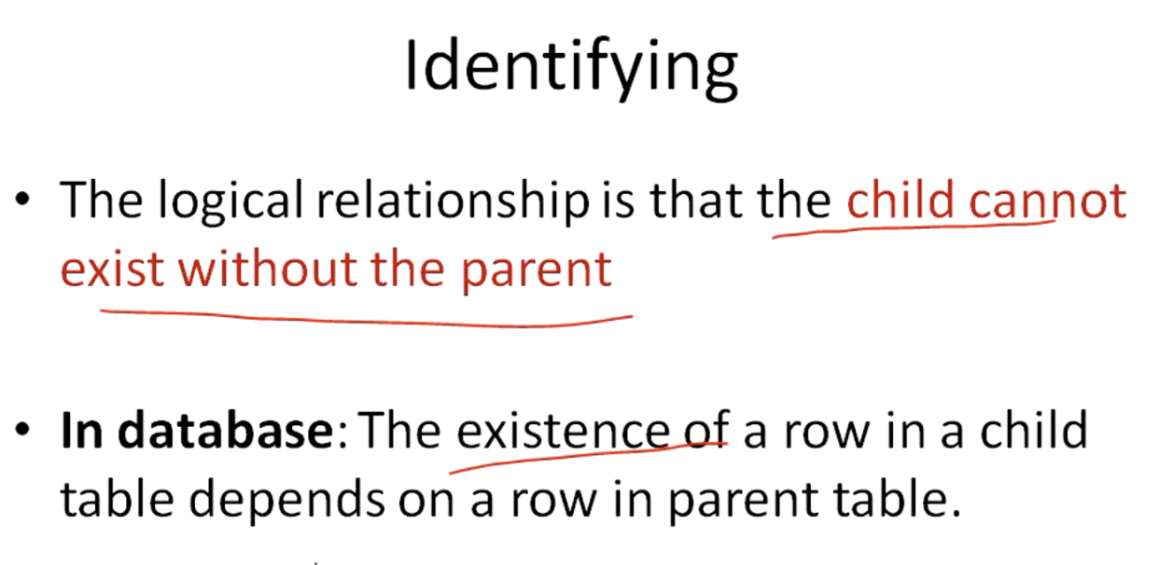

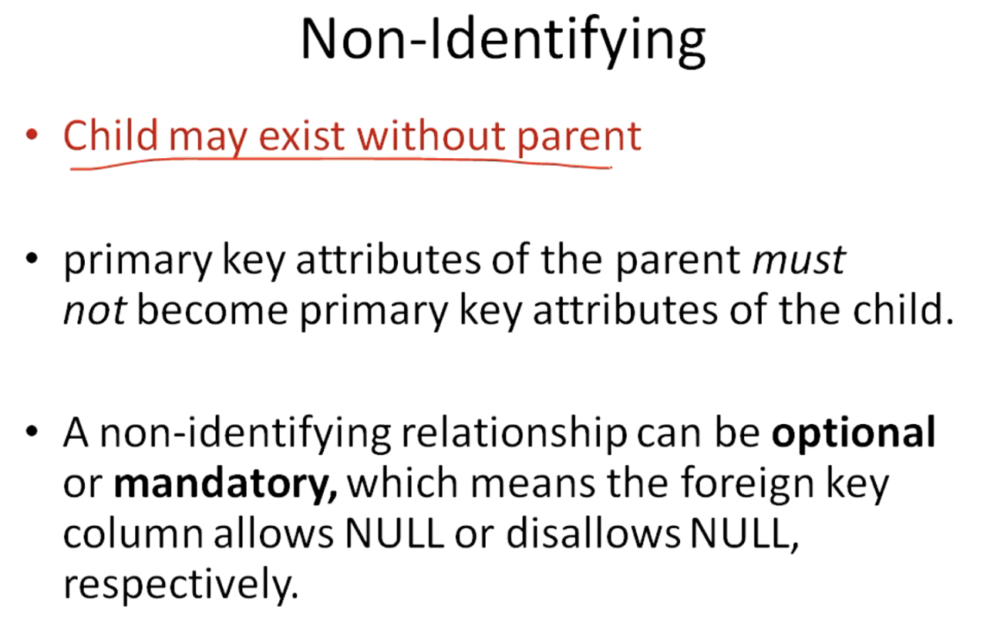

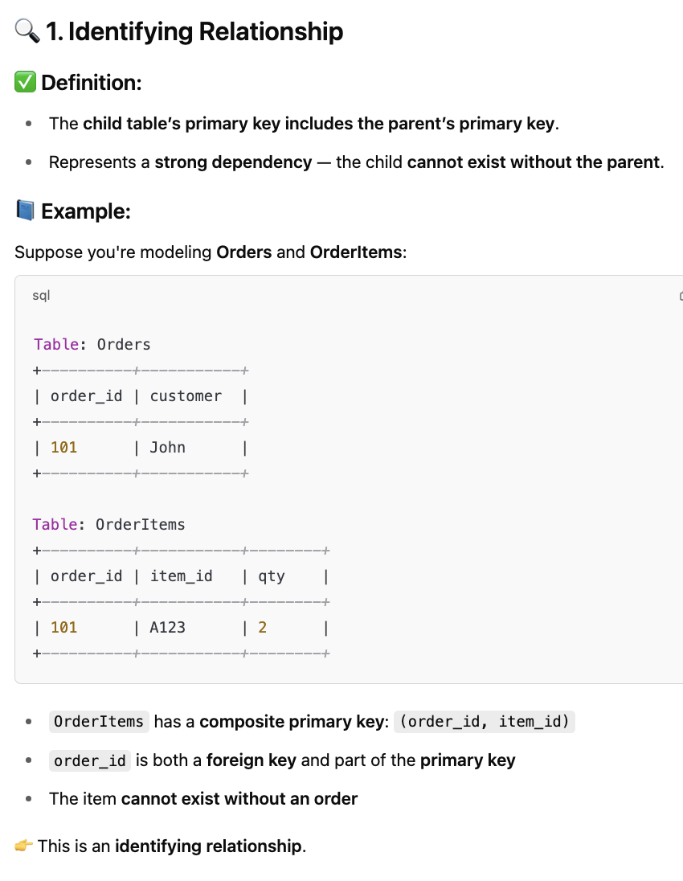

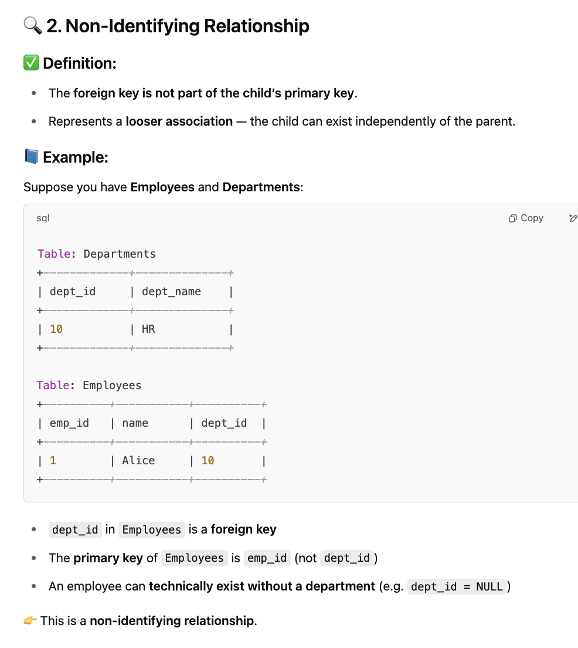

Many to Many:

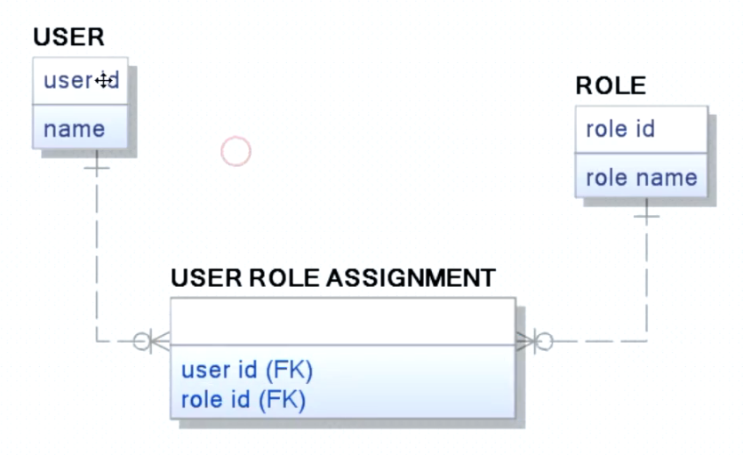

Recursive Relationship:

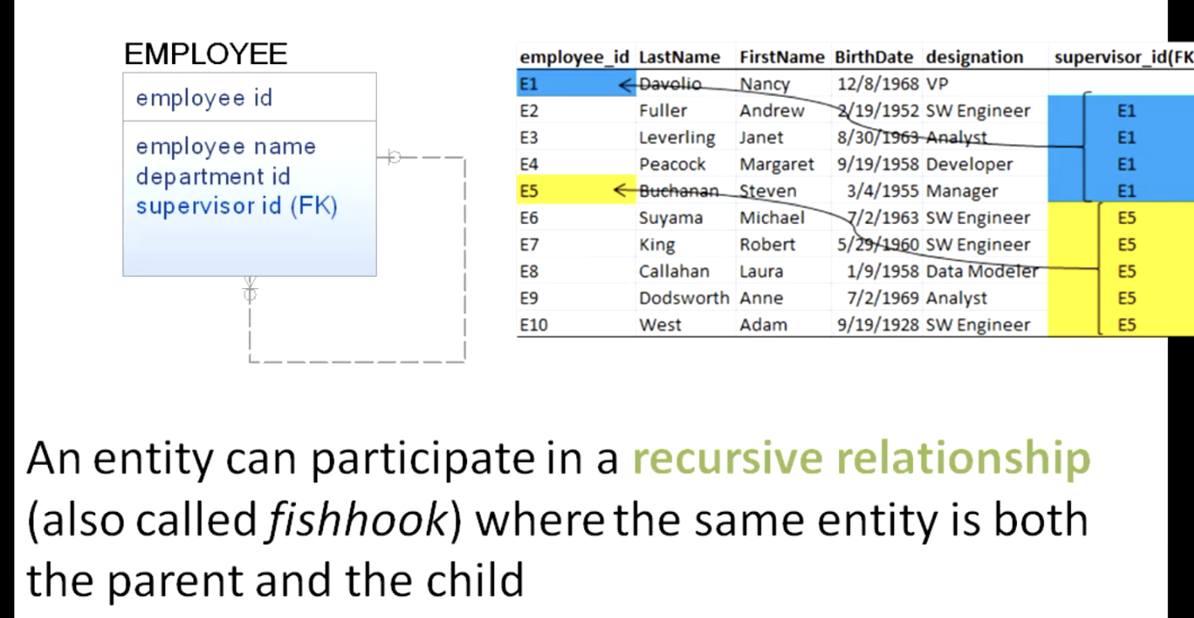

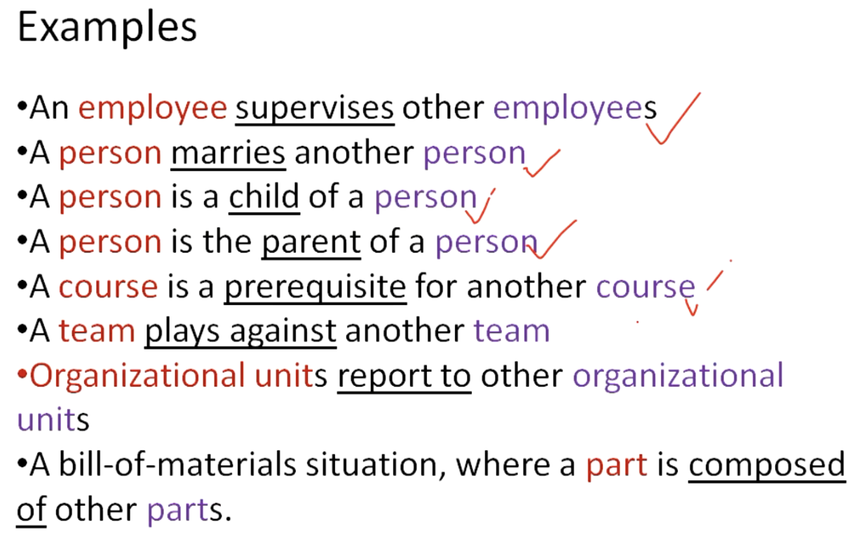

Super & Subtype Relation:

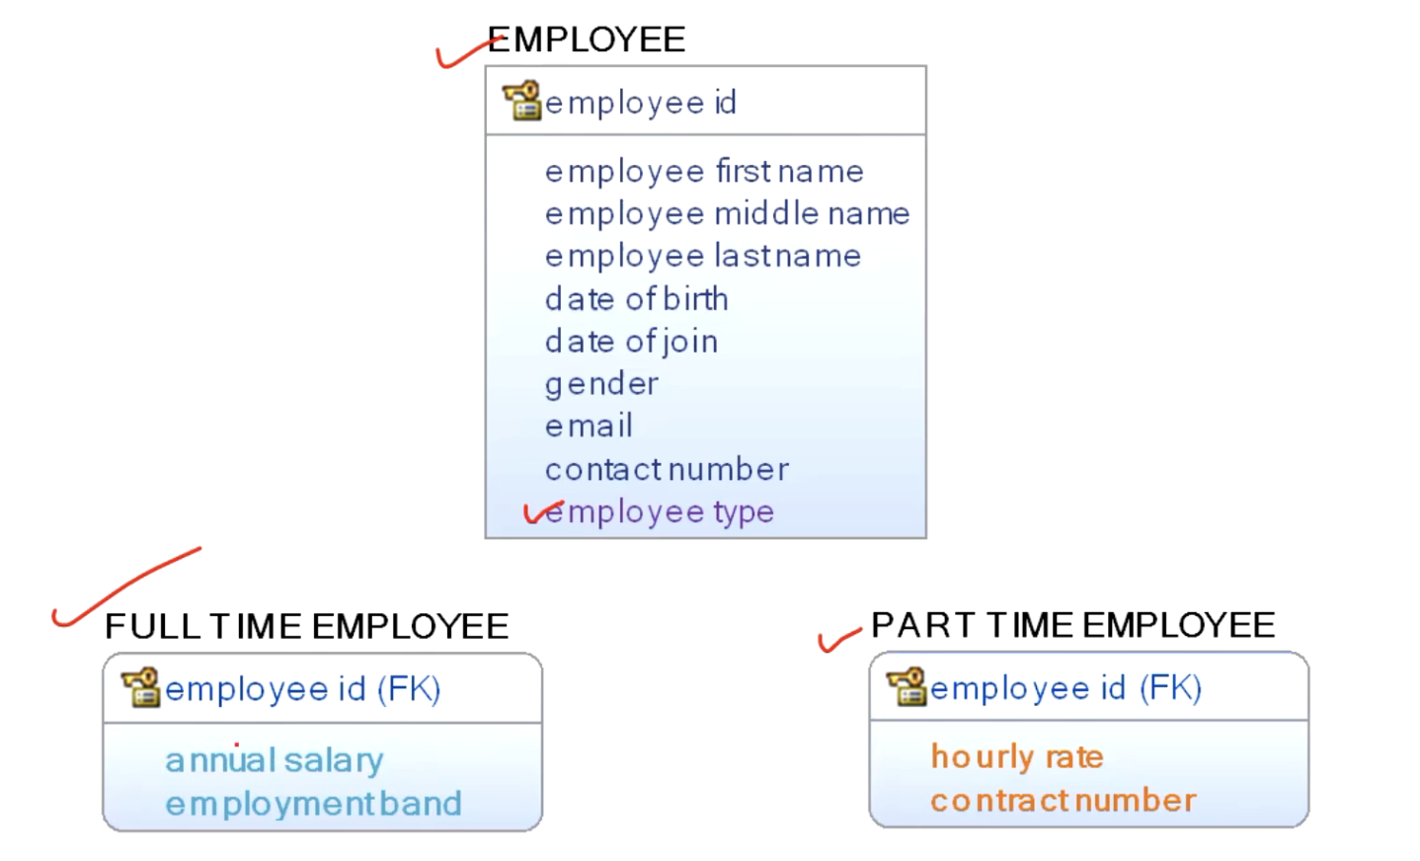

Banking Data Model:

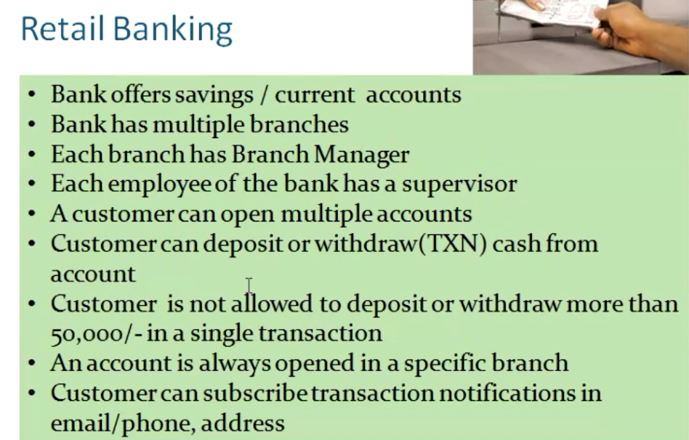

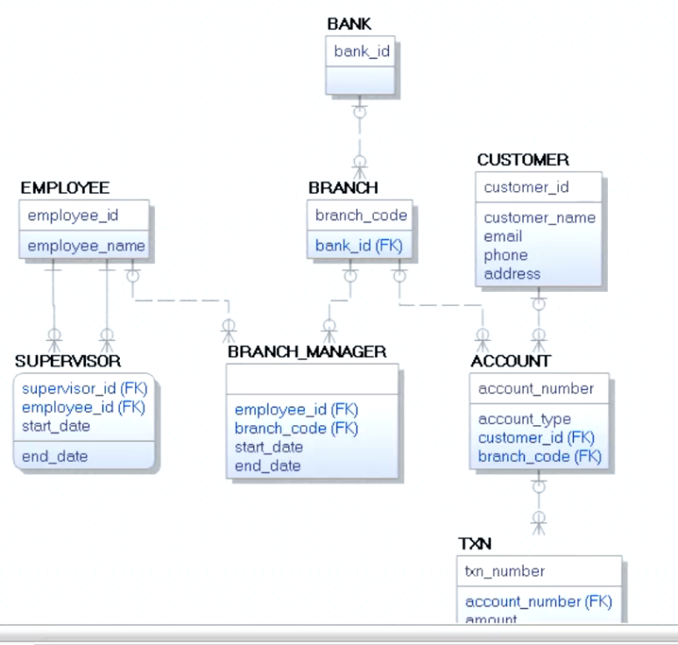

Now let's do a data modeling exercise. We have a set of requirements for developing a retail banking information system. We will analyze these requirements and develop a conceptual, logical data model. The process we are going to follow is we will go through the requirements line by line. When we identify any potential entity, we will mark them and then we will create those entities in a data model. So let's go through these requirements. So this is a set of requirements for developing a retail banking information system. Customers can come and open bank accounts and they can perform transactions with respect to those accounts. So bank offers savings or current accounts. Do we have any significant entity here? We can consider bank as something which is very significant. Another important thing mentioned here is accounts. Let's go to the next line. Bank has multiple branches. Let's consider Branch here. Since this is a retail banking system, Branch is an important entity. Each branch has a branch manager. We have already considered branch. Let's mark Branch manager here. Each employee of the bank has a supervisor. In this line we can find employee, which is something very important. Bank has supervisor. Let's go to the next line. A customer can open multiple accounts. We have a customer here, can open multiple accounts, accounts we have already considered. Let's go to the next line. Customer can deposit or withdraw cash from account. Here customer we have already considered as a possible entity, deposit or withdraw are transactions performed by customer. So let's consider them in collectively as transaction. It's an event performed by a customer in the context of an account we have already considered account. Let's go to the next customer is not allowed to deposit or withdraw more than 50,000 in a single transaction. Here, transaction and customer. These are the potential entities that we have already considered. And but there is a business rule mentioned here that we will include to our model later. Let's go ahead. An account is always opened in a specific branch. Account and branch we have already considered. Let's go to the next line. A customer can subscribe transaction notification in email, phone or address customer we have already considered. Transaction is considered transaction notifications from a data point of view. We need to collect email, phone and address. There may be some additional information handled for sending transaction notifications, but let's ignore them. The next step, what I'm going to do is we are going to create those entities. We will create a new model. We have not added any key in the branch manager or supervisor because they are role of employees. A branch manager is a role of an employee with respect to a branch and supervisor is the role of an employee with respect to another employee. So let's keep them and we will model that later. Here customers should be having email, phone or address. Let's see if there are some very clear relationships mentioned here. Bank offers savings or current accounts. Let's include an attribute. This account type attribute will identify an account is of which type. Bank has multiple branches. So let's create a one to many relationship from bank and branch. Next. It says each branch has a branch manager. Branch manager is going to be an employee. A very simple way of modeling that aspect should be by creating a one to many relationship from employee to branch. Because a branch manager is an employee here we have an additional attribute in branch entity, which is the employee ID man for a branch manager so we can role name this relationship to branch manager ID. Each employee of the bank has a supervisor. One simple way to model supervisor for each employee is by introducing a recursive relationship. And let me change this role to supervisor ID. One problem with this approach is over a period of time, if one particular employee has different supervisors, we won't be able to capture that information here because one instance of an employee can only remember one supervisor. If we have to make this system capable of dealing with multiple supervisors for the same employee concurrently or over a period of time, we need to create an association table. So I'm going to delete this relationship and then let's. Use the supervisor. Where we are going to create two relationships. One is employee ID coming here as an employee and another one is employee ID coming there as a supervisor ID. See, we have supervisor ID. Employee ID for each employee supervisor relationship. There will be a start date and end date. Supervisor entity. Similar way, if we want to model the branch manager based on the current design, we can have only one branch manager captured by this system. So if we want to capture multiple branch managers, we cannot model it with a single relationship line. Instead of relationship line, we are going to use a separate entity called a separate entity called branch manager. Draw a relationship from employee and draw a relationship from branch, an employee and a branch coming together where employee is playing the role of a branch manager. Let's add a start date and end date for this relationship. Okay, so we have branch manager. We have supervisor. We have account customer and transaction. A customer can open multiple accounts. So let's relate customer and account such a way that a customer can open multiple accounts. Each account remembers a customer ID. A customer can deposit or withdraw cash from accounts so transactions can be performed by customer. So let's create a relationship from customer. It is going to be a one to many relationship because each customer can perform many transactions. So these transactions are meaningful only when we know in which account the transaction happened. So we need to have a relationship from account to transaction because for each account there can be many transactions. So there is a one to many relationship. But if we know the account number implicitly, we know who is the customer. So the relationship from customer to transaction is now redundant, so I'm going to delete that. We need only the relationship from account to transaction. A few columns here. Okay. Customer is not allowed to deposit or withdraw more than 50,000 in a single transaction. So that's a constraint on this particular attribute. Within a transaction, we have amount attribute that cannot be more than 50,000. So what we have to do is we have to include a constraint. One way to create that constraint is go to the attribute properties. The second page, you notice that this is a constraint page. Create a new constraint and it is going to be a validation rule. Go in here. I have named it transaction limit and the type of the constraint is a min max constraint. I put 0 to 50,000. So we have already attached the constraint with amount. An account is always opened in a specific branch, so accounts are associated with a branch. So I'm going to create a relationship from branch to account. Each account belongs to a branch and each branch has multiple accounts. Customer can subscribe transaction notifications. We need email, phone and we have already included them. So this is a character design that we have made and we can forward engineer this to a database. Let me switch over to physical side. The next important thing we have to do is to set the data type for all columns. Right now we can see car 18, which is the default data type assigned for transaction table. You can find the constraint here. Amount has a constraint that which checks the amount between 0 and 50,000. Other than that, we have all the tables and corresponding indexes. And also finally we have foreign keys. Thank you.

Dimensional Modelling:

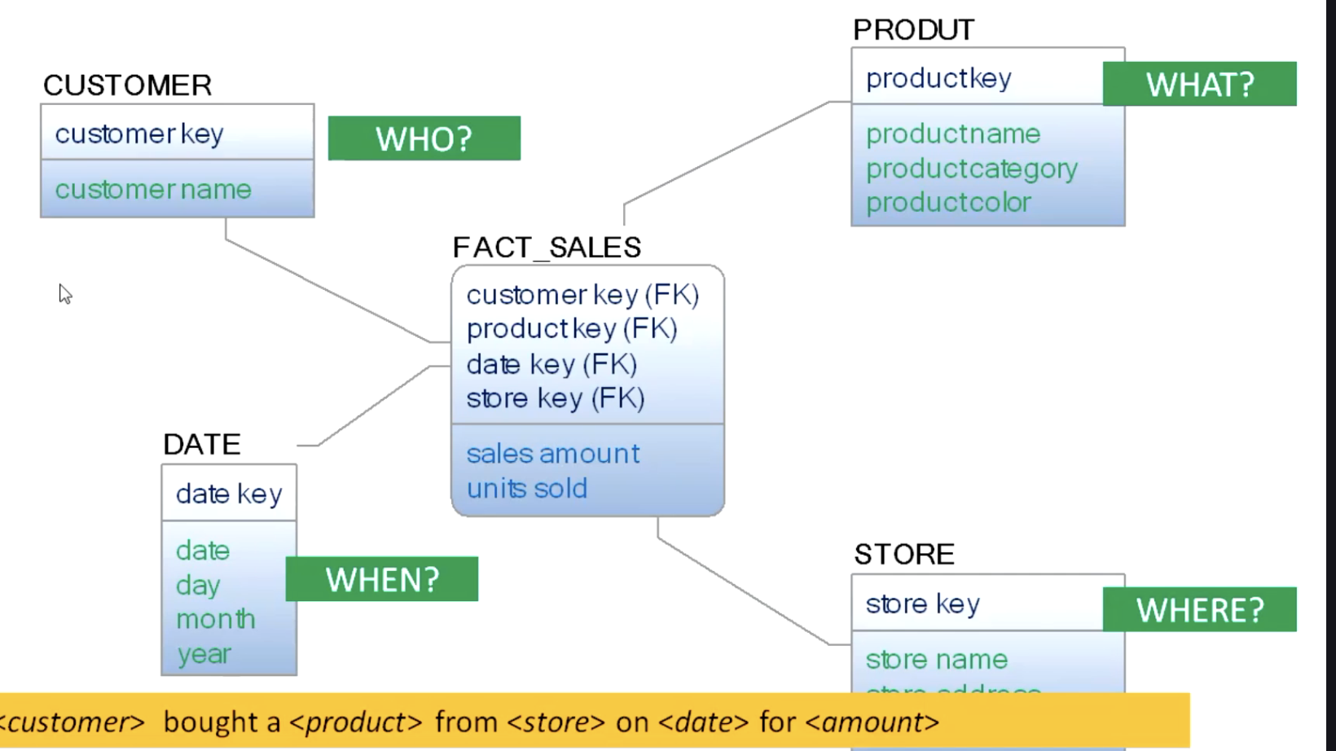

Dimensional modeling is a set of techniques optimized for delivering analytic data with greater attention on understandability and performance. This is achieved by organizing data into facts and dimensions. We call this a dimensional model or often a star schema. A star schema is composed of fact tables and dimension tables. Facts are measures about an event being analyzed. Dimensions describe them with appropriate contextual information. For example, if we intend to analyze the performance of a business, the measures or facts could be revenue, the number of products sold, or any other key performance indicators that indicate the business performance. The dimensions could be product, customer date, location and so on. Dimensions Help us to put the facts into perspective. It answers the questions around the fact who did what, when, why, how, etcetera. In next few lessons, I will show you how to develop a dimensional model using Erwin.

